
Certificate of Absence
Section A (Completed by Finance & Admin Manager on the first day of absence)
Staff Name:

First date of absence from  work: |  | Why you were off work:    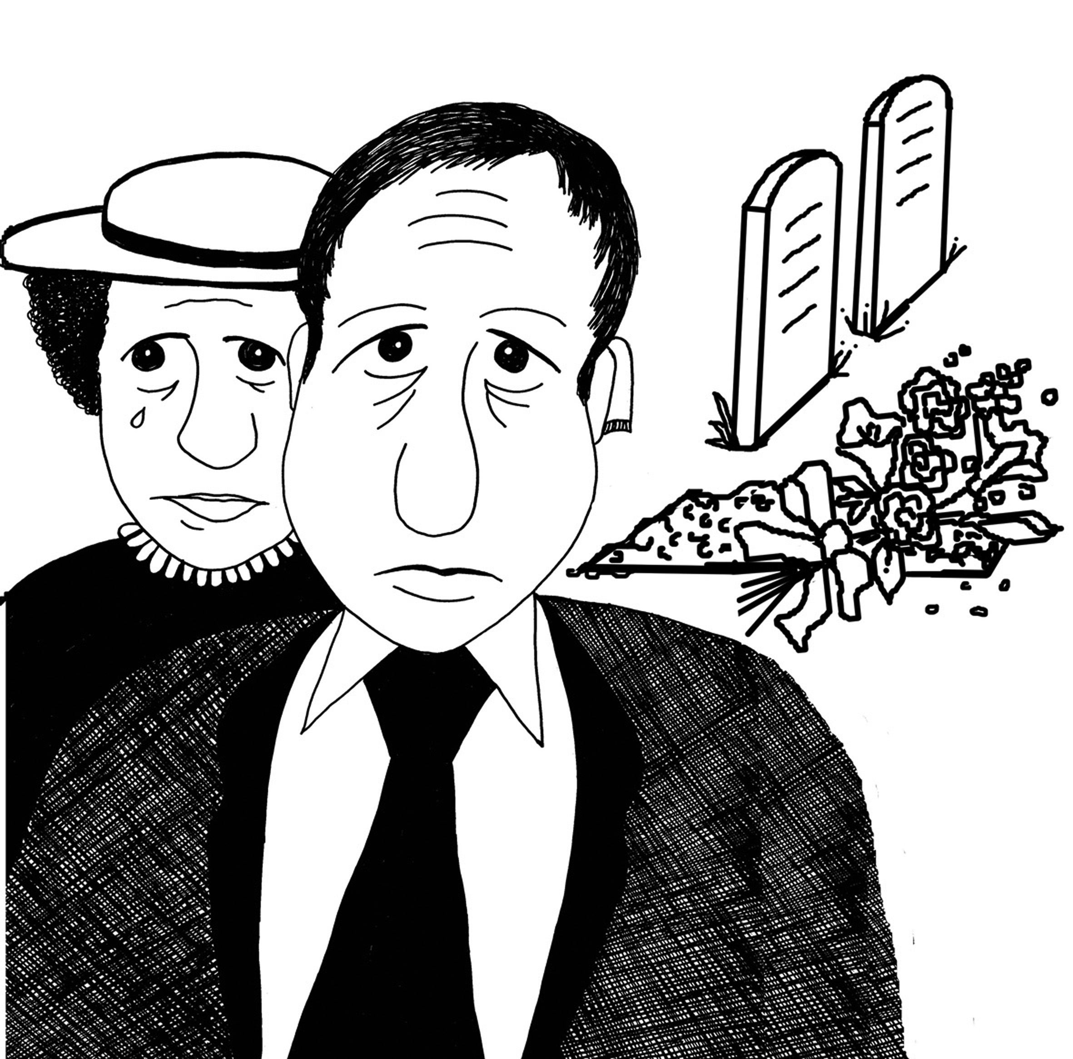      Sick Carers Leave Emergency Leave Bereavement
If you left work early, what time did you finish?

Section B (Completed on return to work by Staff member)
Total number of days Absence: | Date returned to work:
Why you were off work?:

Please do not state ‘ill or sick’ – please give as much information as possible.

Declaration I declare that the above information is correct. I understand that if I deliberately give any wrong information it could result in disciplinary action.

Employee’s Signature ___________________________________ Date __________________________

Line Manager’s Signature ________________________________ Date __________________________

