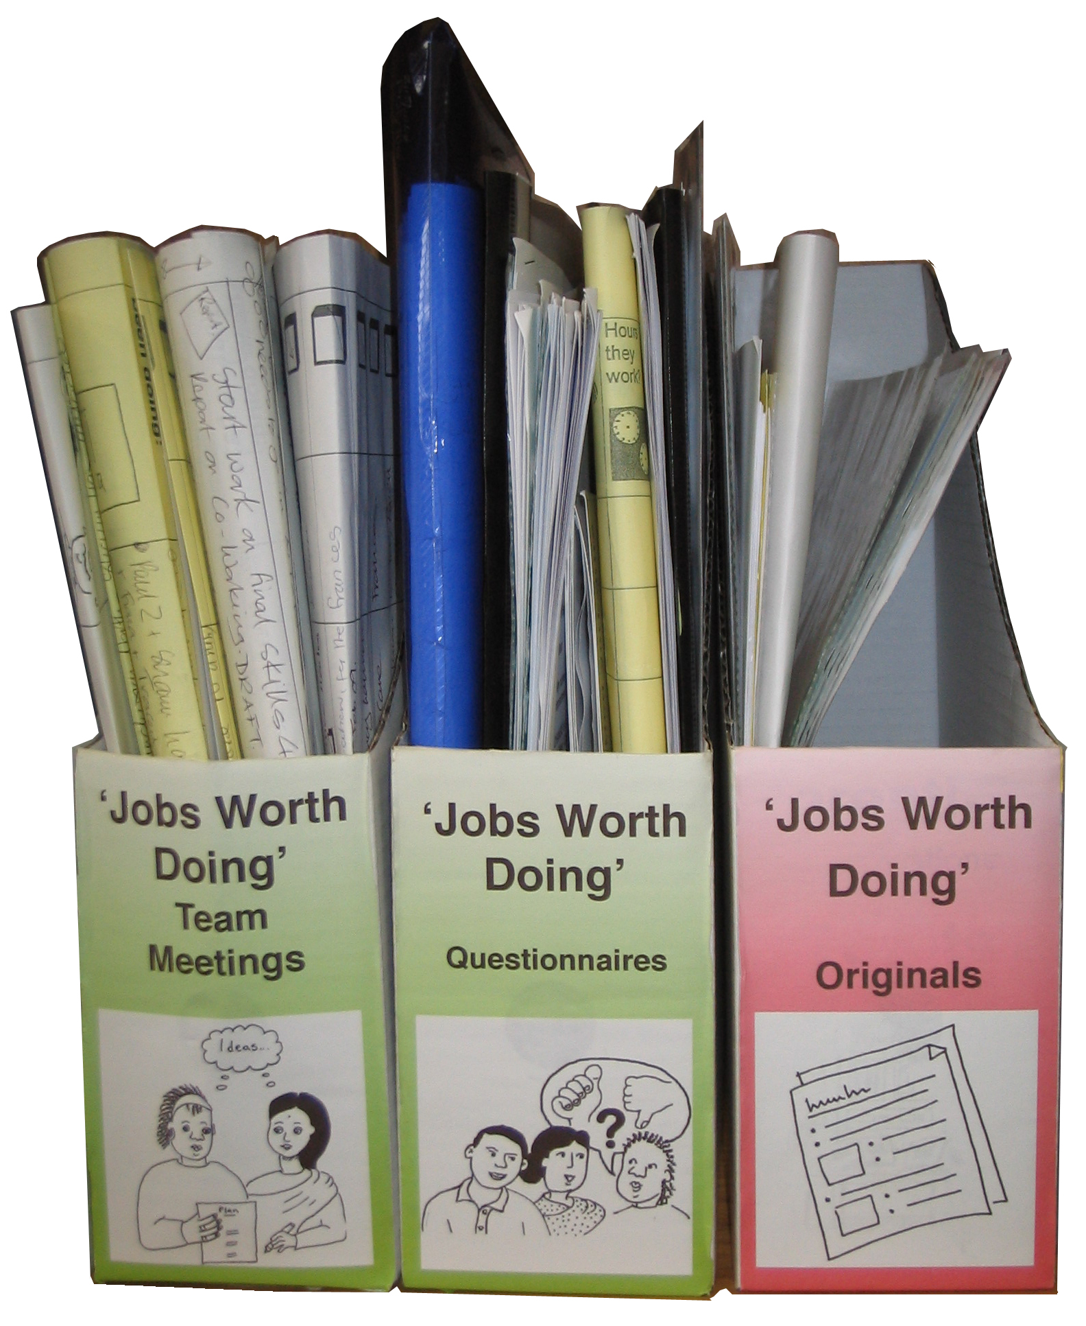
Labels

Box files
Area of work

Subject
Area of work

Subject
Area of work

Subject
Area of work

Subject
Area of work

Subject

