Budget Information

Name of your Organisation: _________________________________

Name of your Project: ______________________________________

Please tell us how much this project will cost to run

STAFF COSTS: |  | How much you plan to spend
 |  | Dates | Dates
 |  | From: To: | From: To:
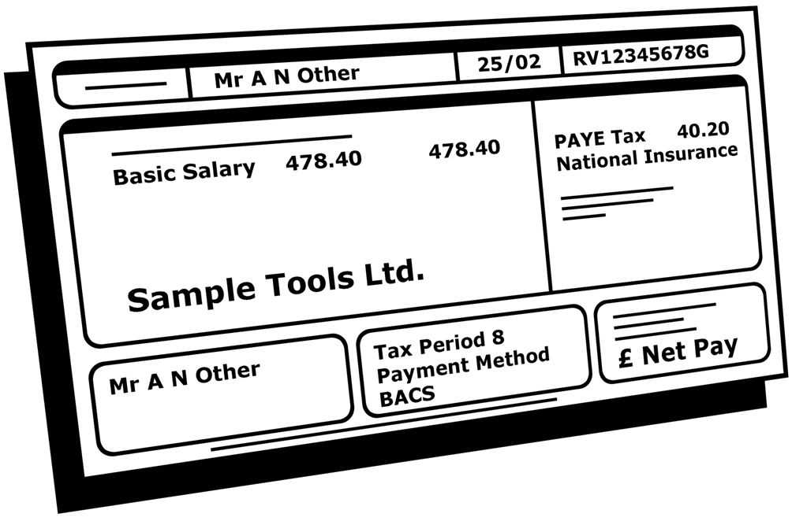 | Salaries
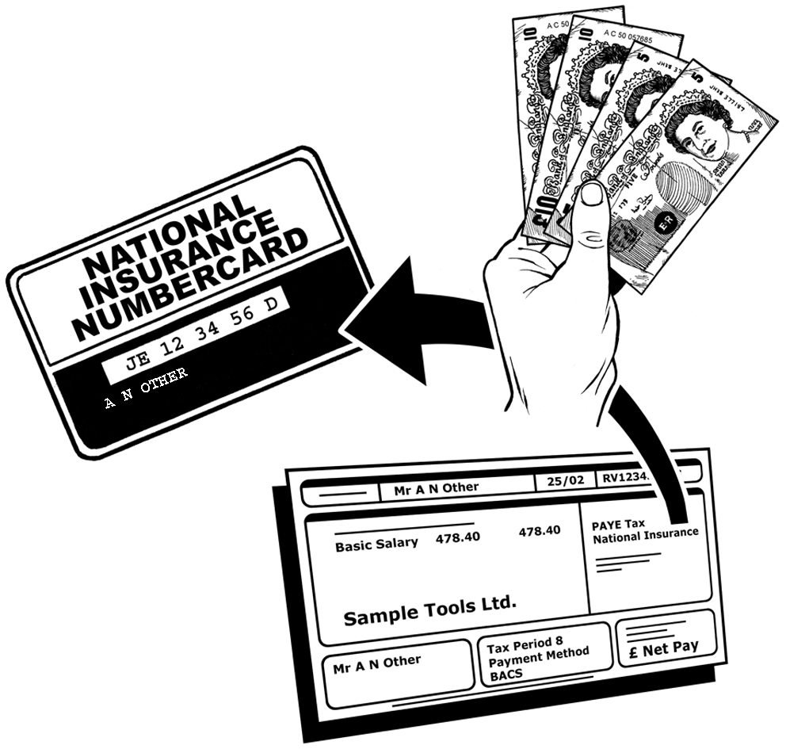 | National Insurance (employers only)
 | Pension

SUB TOTAL

ACCOMMODATION COSTS: |  | From: To: | From: To:
 | Rent
 | Heating & Lighting
 | Maintenance & Insurance

SUB TOTAL

OTHER COSTS: |  | From: To: | From: To:
 | Post, Telephone and Fax
 | Printing & Stationery
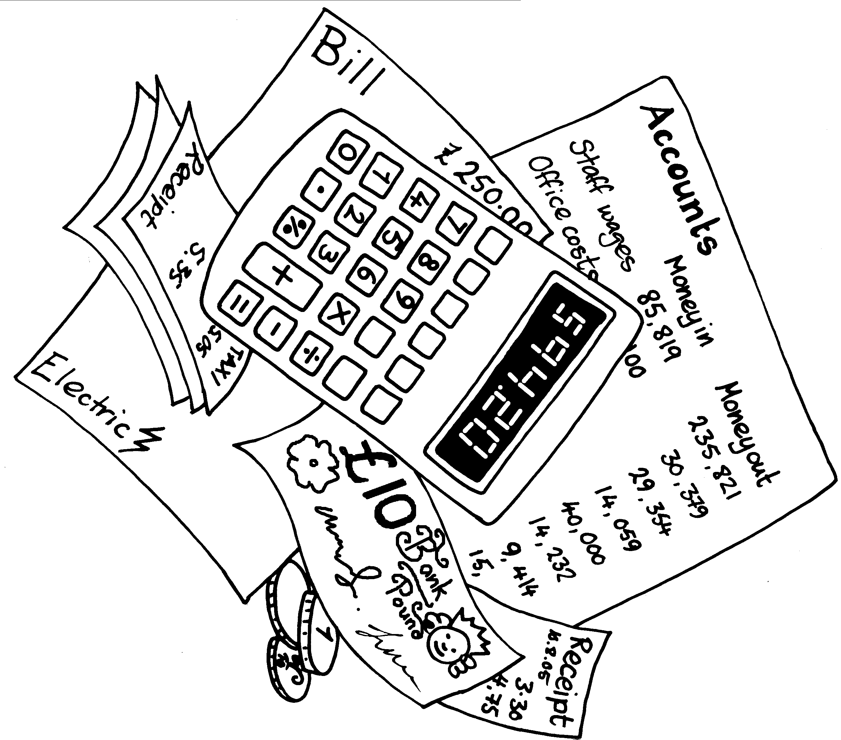 | Audit & Legal
 | Travel Expenses
 | Training Expenses
 | Evaluation Costs
 | Extra costs for making sure people know about your work
 | SUB TOTAL
TOTAL
 | Any extra costs (including capital items) e.g. Volunteer expenses

Total including EXTRA costs

