
Co-workers Supervision notes:
Project: ______________________ Date: _______

Workers name:

How we are feeling about work?


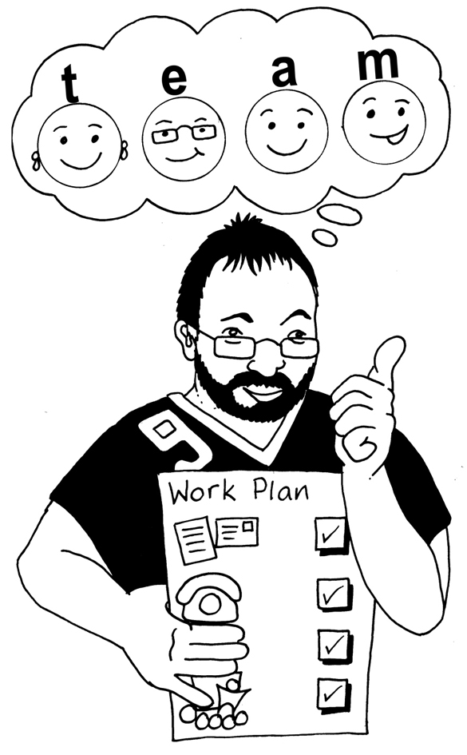
What we have been doing?

Are we on target?
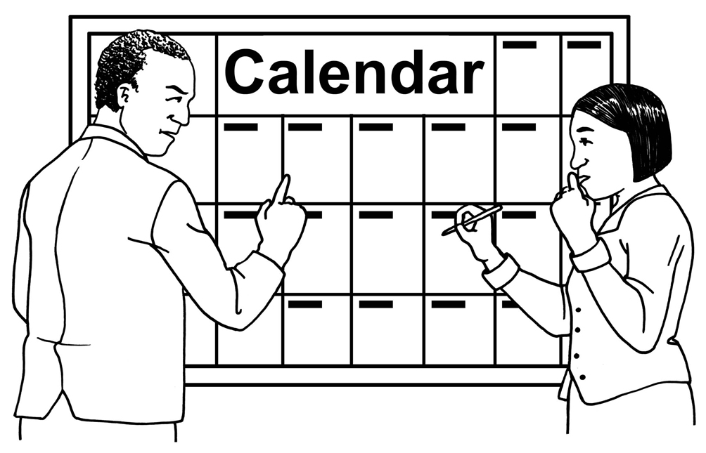

What we are going to do next?
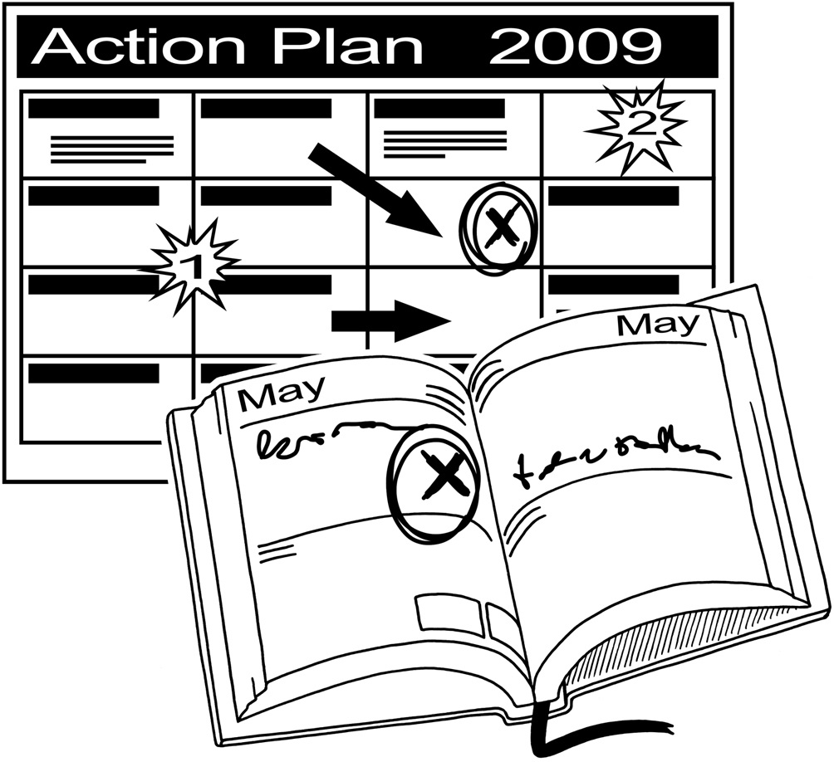

 | Budget – what we have spent, what we have left?
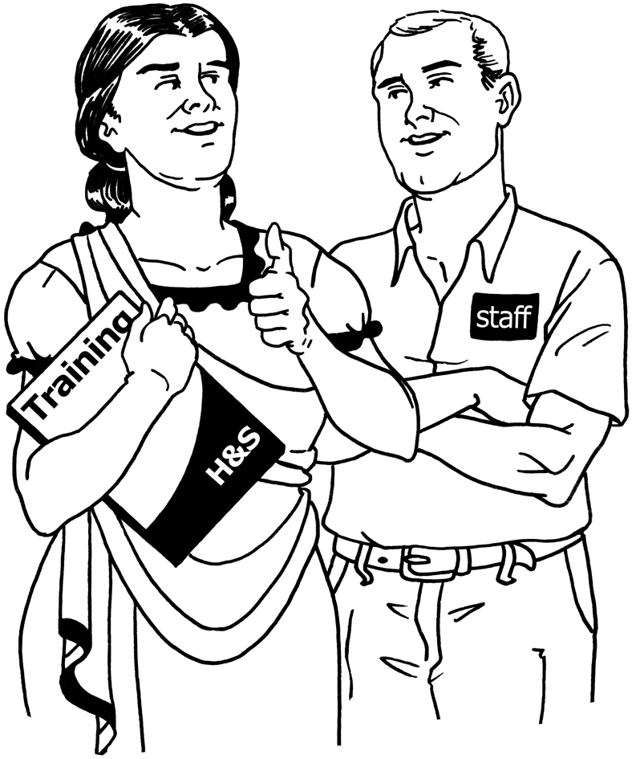
Training
we would
like to do?

Action points: |  | Do by:
Things that need to be done: |  | Who will do it? | Done
 |  |  | ❑
 |  |  | ❑
 |  |  | ❑
 |  |  | ❑
 |  |  | ❑
 |  |  | ❑
 |  |  | ❑
 |  |  | ❑
 |  |  | ❑
Date of next co-workers supervision:

