
CRB Disclosure
Finding out if you have a criminal record and what we will do with this information

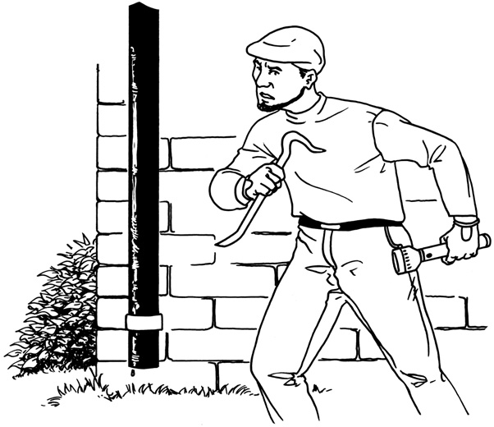
What we will do: As an organisation we will use the Criminal Records Bureau (CRB) Disclosure service to help find out if applicants for positions of trust have had a criminal record.
?

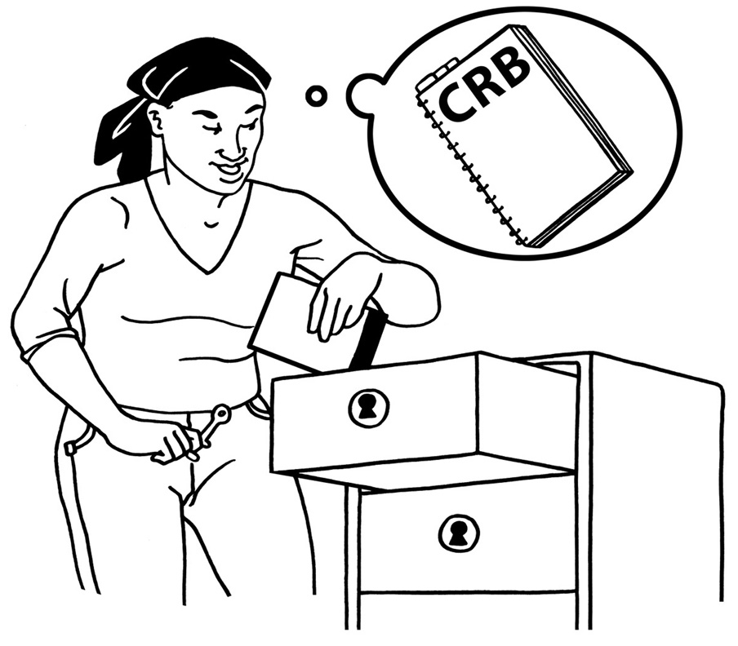
We will follow the CRB Code of Practice about the correct handling, use, safe storage, keeping and disposal of Disclosures and Disclosure information.


We will also make sure we do everything that the Data Protection Act and other laws about safe handling, use, storage, keeping and disposal of Disclosure information say we must to do.

We have a written policy about this, which anyone can ask to see.

Storage & Access
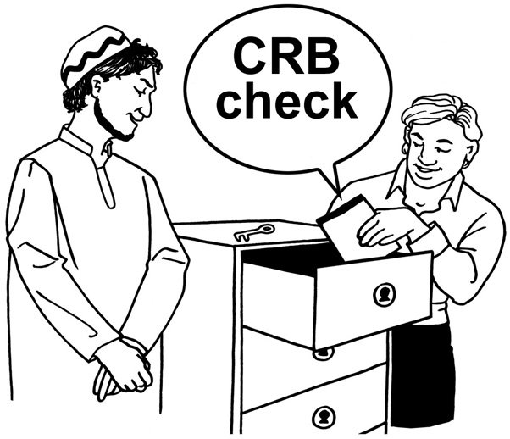
Disclosure information is never kept in an applicant’s personnel file. It is always kept separately and safely, in lockable storage containers that cannot be easily carried away.

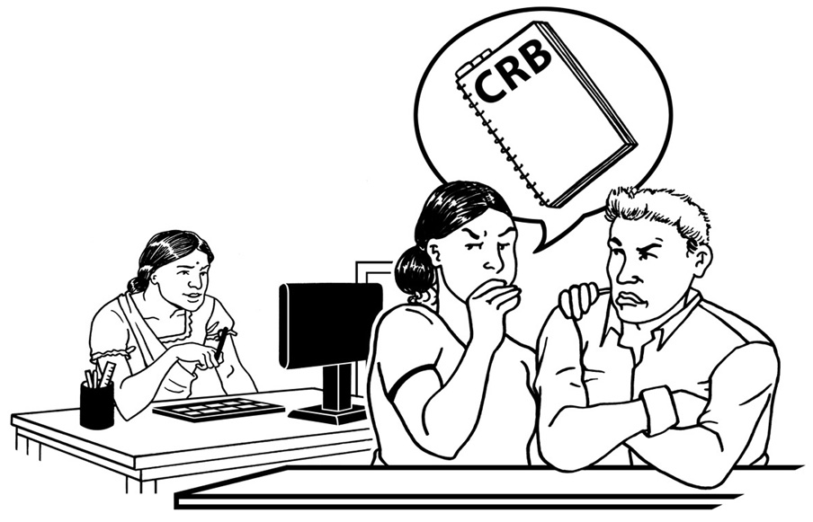
Access is strictly controlled and limited to those who are entitled to see it as part of their duties.


Handling
Following section 124 of the Police Act 1997, Disclosure information is only passed to those who are authorised to receive it as part of their duties.

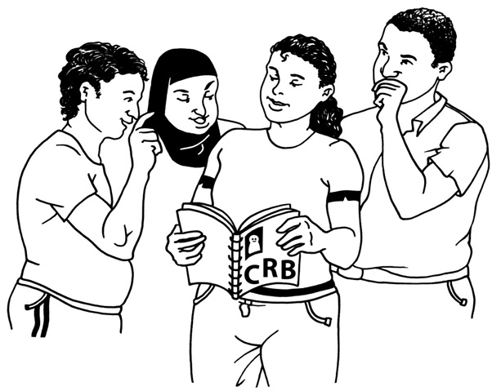
We keep a record of all those to whom Disclosures or Disclosure information has been shown.

We understand that it is a criminal offence to pass this information to anyone who is not entitled to receive it.


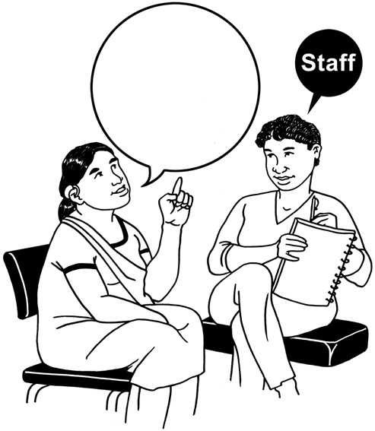
Usage
CRB
Yes
Disclosure information is only used for the specific purpose for which it has been requested. It will only be used if the applicant agrees to give their permission.



However if you do not give permission for a CBR check to be done on you it may mean that we will not be able to let you work in positions of trust or with vulnerable people.

Keeping
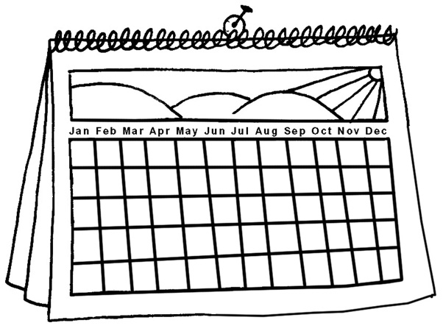
Once we have decided whether
or not to employ someone,
we will not keep Disclosure information for any longer than
we need to. We usually keep information for up to six months, in case anyone disagrees or complains about any decision we make based on a CRB check.


If, there is any special reason to keep Disclosure information for longer than six-months, we will ask the CRB about this.

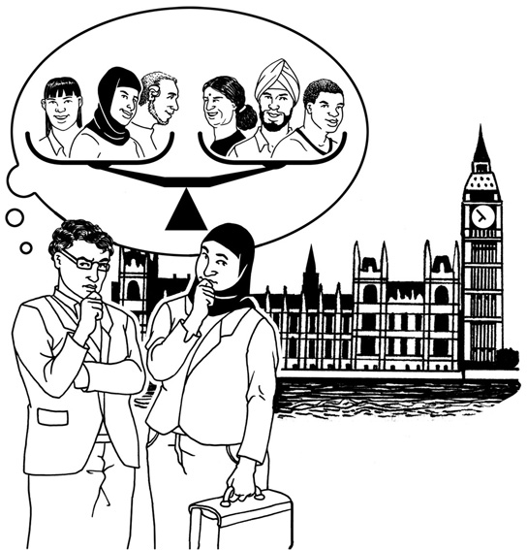
We will think very carefully about Data Protection and the Human Rights of the individual that the information is about before doing so. Throughout this time, we will continue to keep information in safe storage with strictly controlled access only.

Disposal (getting rid of Disclosure Information)
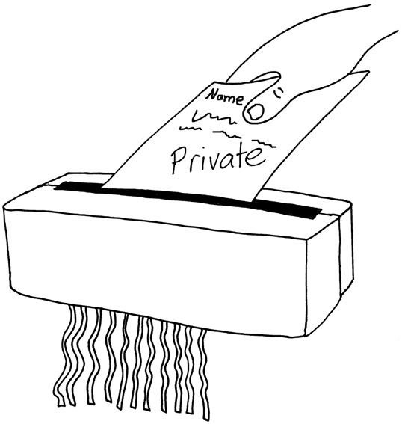
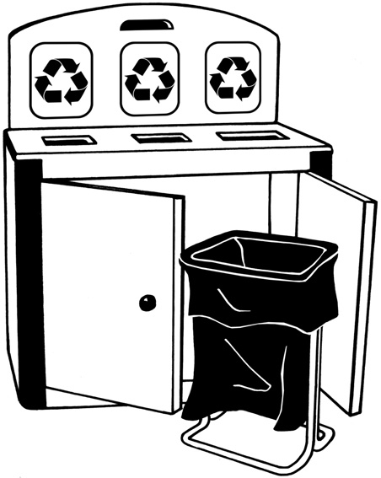
Once the time for keeping information has passed, we will make sure that any Disclosure information is properly destroyed straight away, i.e. by shredding, pulping or burning.

While waiting to be destroyed, Disclosure information will not be kept anywhere that people can see it or take it, (e.g. waste bin or confidential waste sack).

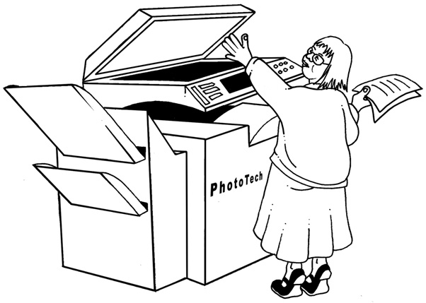
We will not keep any photocopy or other image of the Disclosure or any other notes about what is in a Disclosure.

However, we may keep a record of the date a Disclosure was issued, the name of the person, the type of Disclosure we asked for, the position for which the Disclosure was requested, the unique reference number of the Disclosure and details of whether or not we employed the person.
Staff Checks:

Date: 10/5/10
Name: Fred Bloggs
Job: Project Worker
Type of check:
Enhanced
Ref: B123Z56

Employed by us?
YES

Do you agree to us asking for the Criminal Records Bureau to do a check on you?

YES NO

Agreed on………………….........


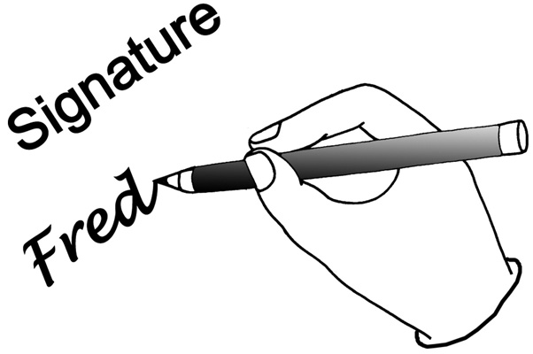

Signed……………………………
.

