Database
Information about People/Organisations that we know or work with
  Name of the  person you  spoke to: |  |  |   Date of call:
Job Title of
this person:

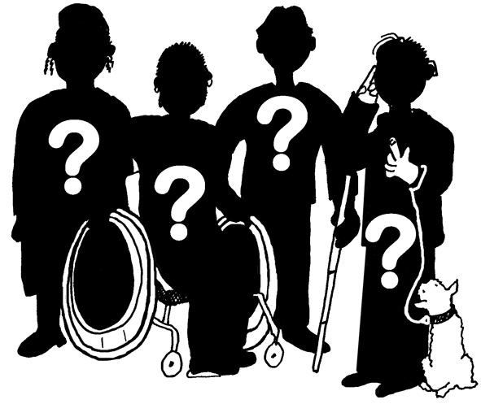
Name of their
Organisation:

 |  |  | 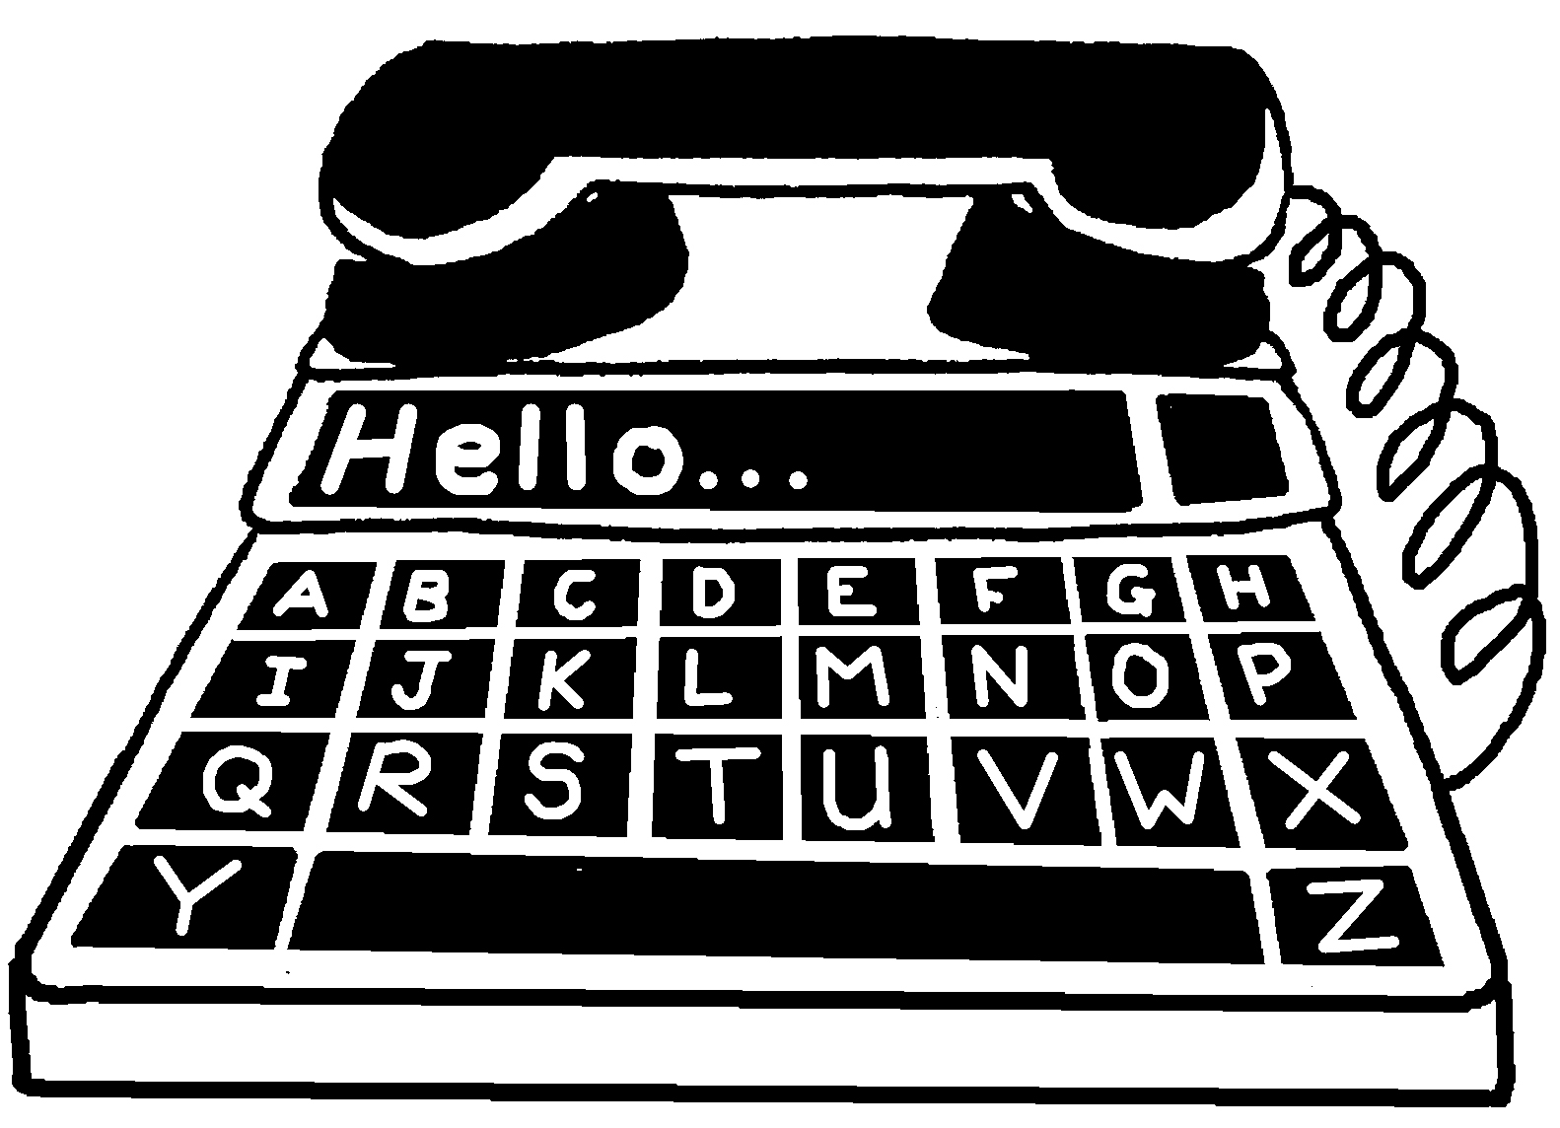
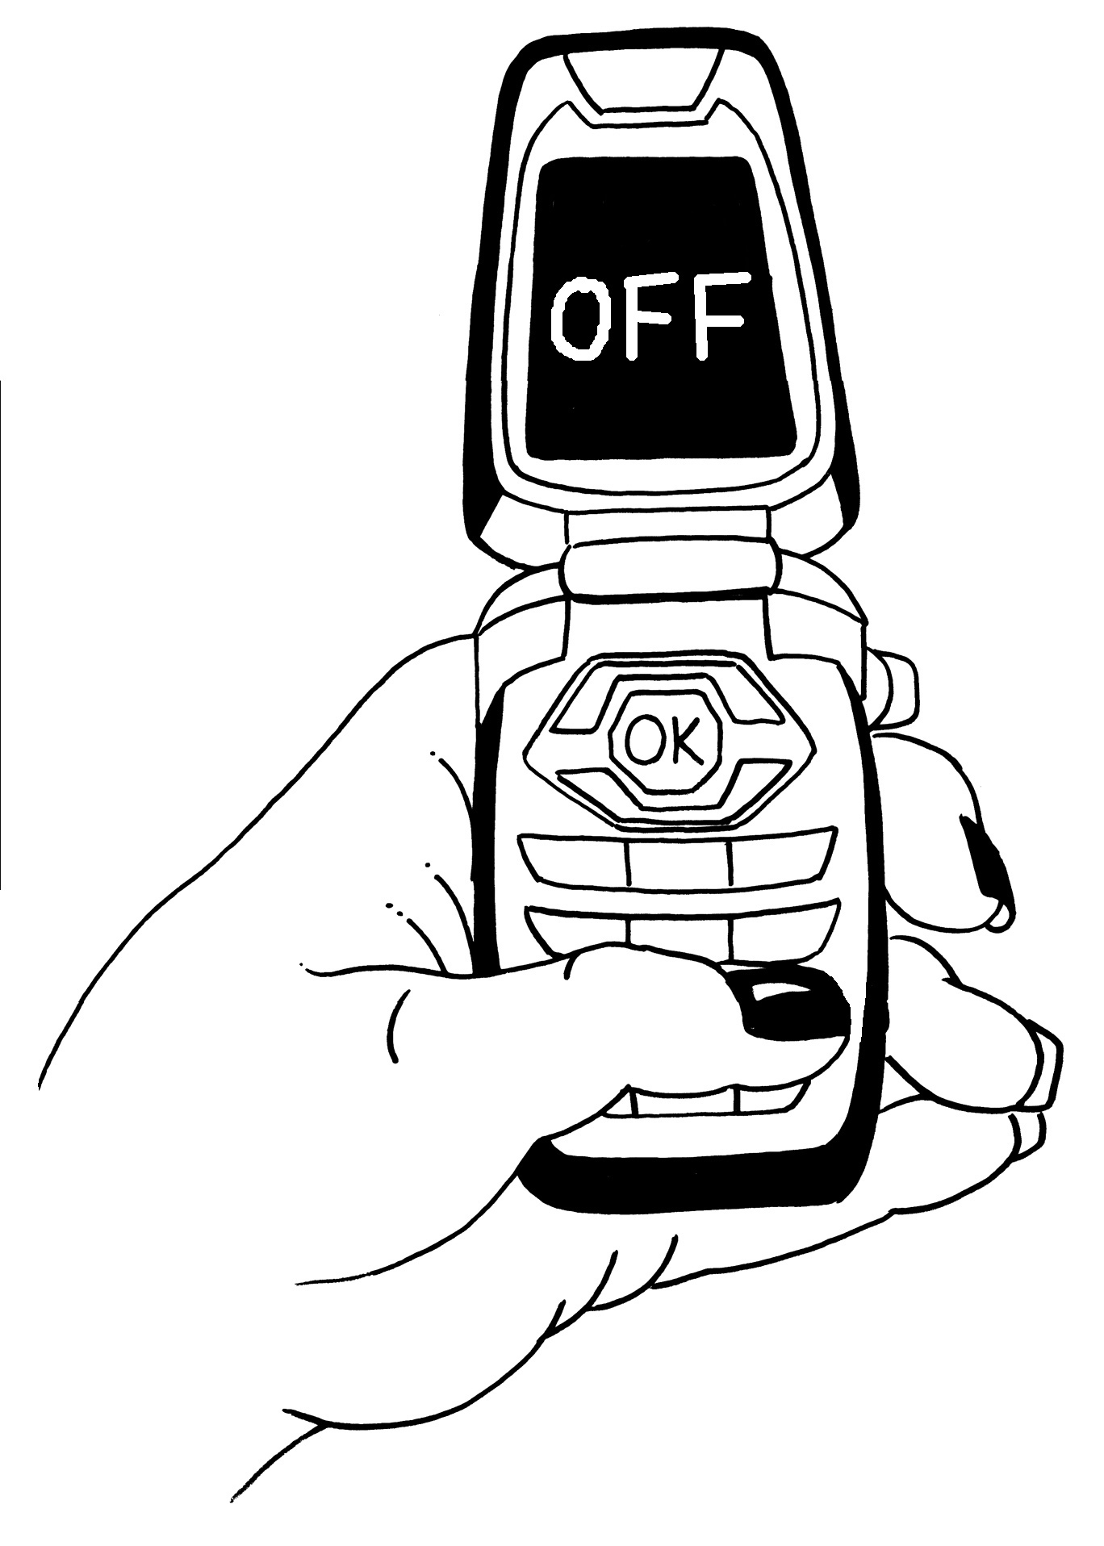 |  |  | 
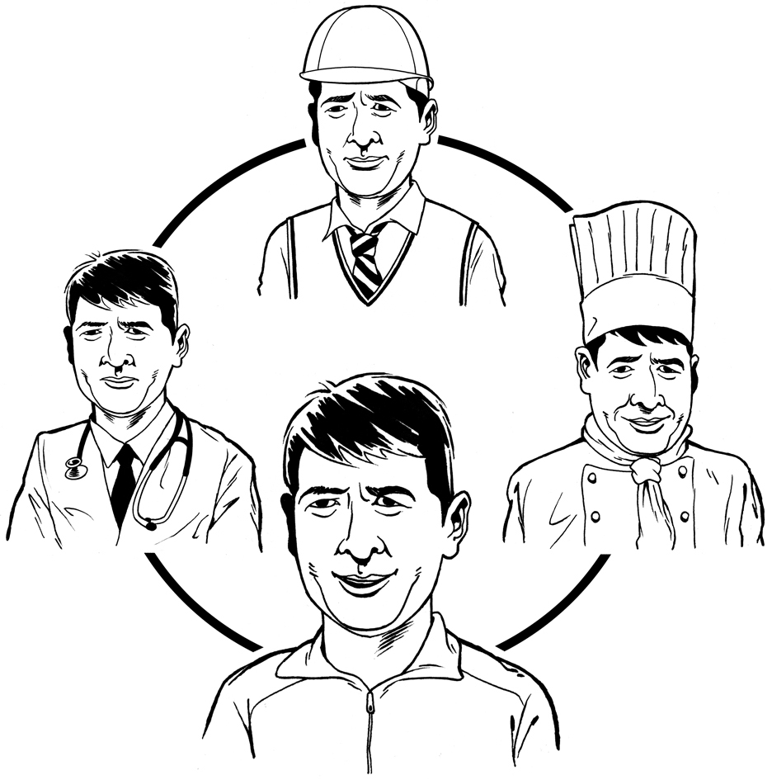  What does  this person/  organisation  do? |  | e.g. advocacy group, healthcare trust, housing association, person with learning disabilities etc.
Why did this person contact us? e.g. asking for more information about a project, wanted to know price for Picture Bank, answered a questionnaire etc.
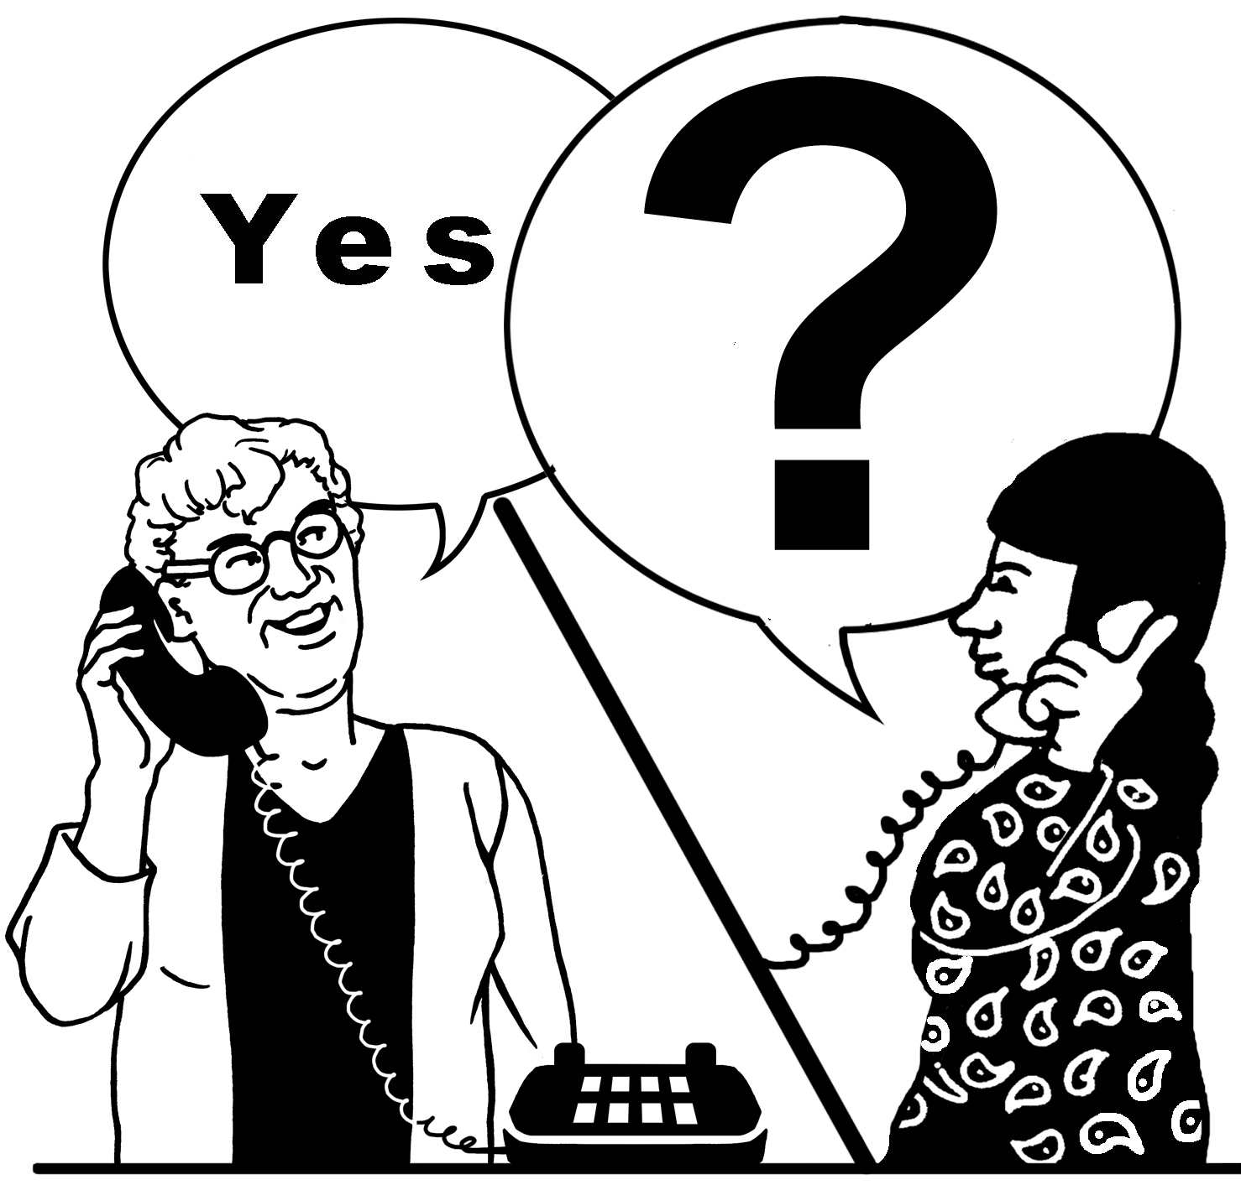

What has happened so far? e.g. sent some information, spoke to them on the phone, had a meeting with them etc.


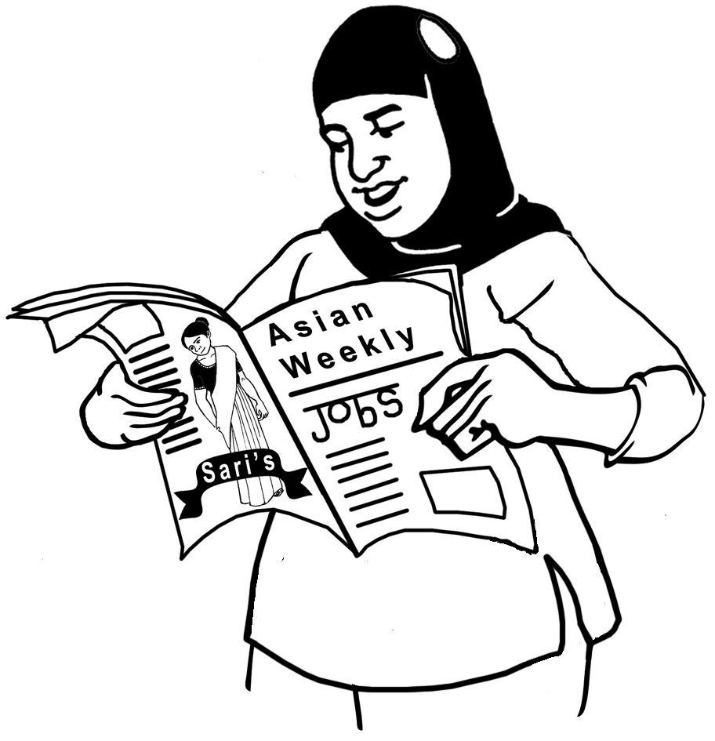  How did this  person hear  about CHANGE? |  | e.g. through a friend/colleague, from an event, saw our website or a leaflet etc.
  Comments - |  | How helpful is this person/organisation?

