Database
Organisations working for people with Learning Disabilities
Name of
Organisation

Telephone | 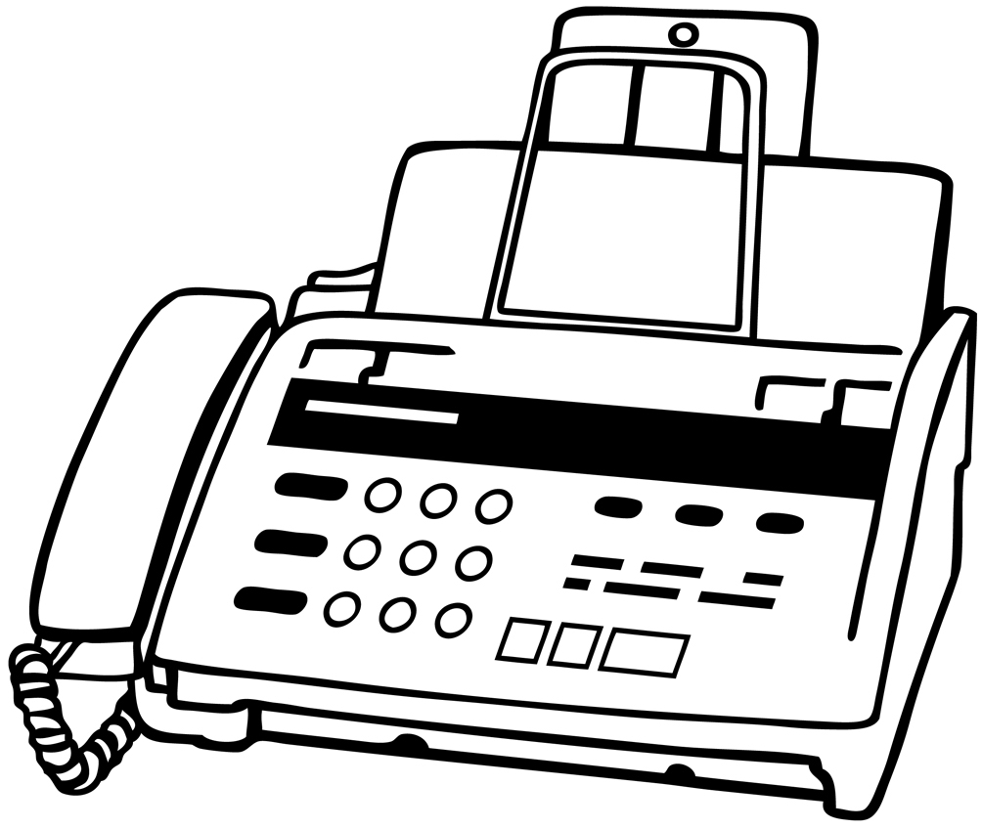Fax | 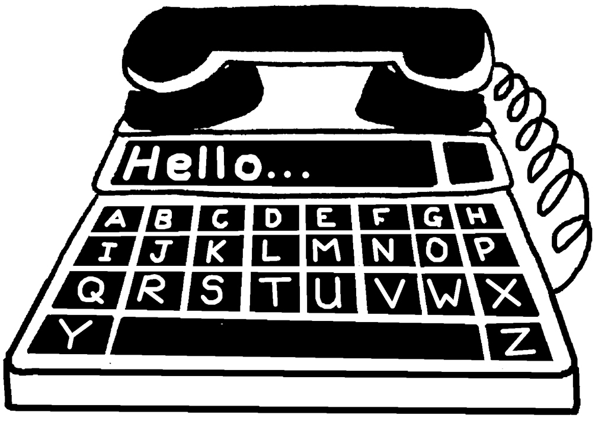Minicom
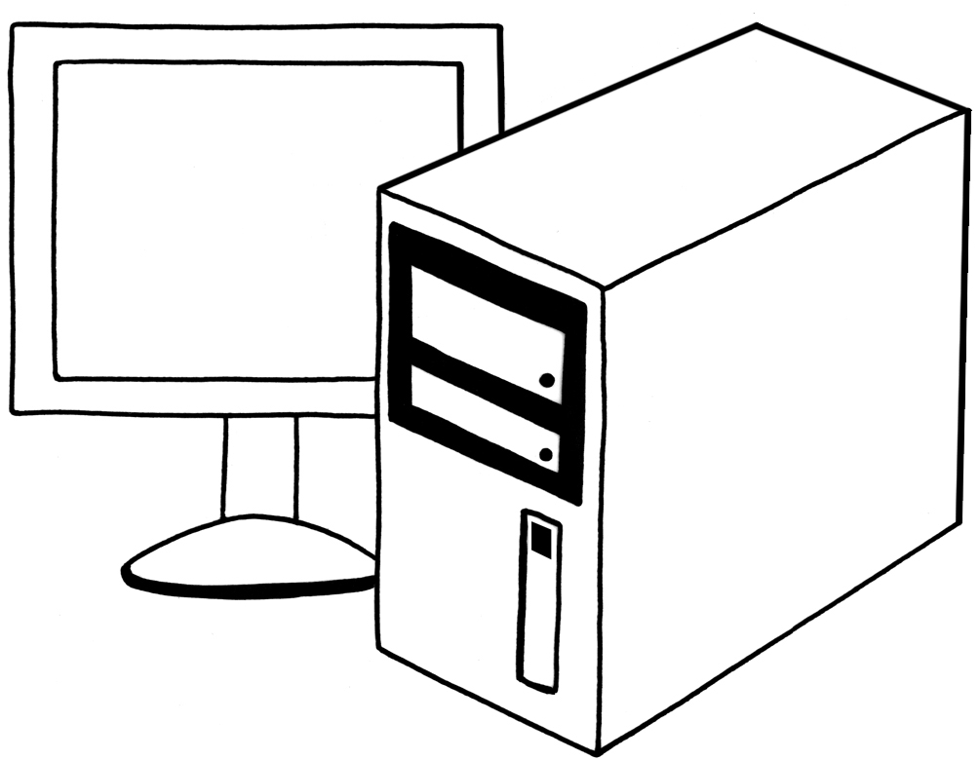e-mail

Helpful person
you know

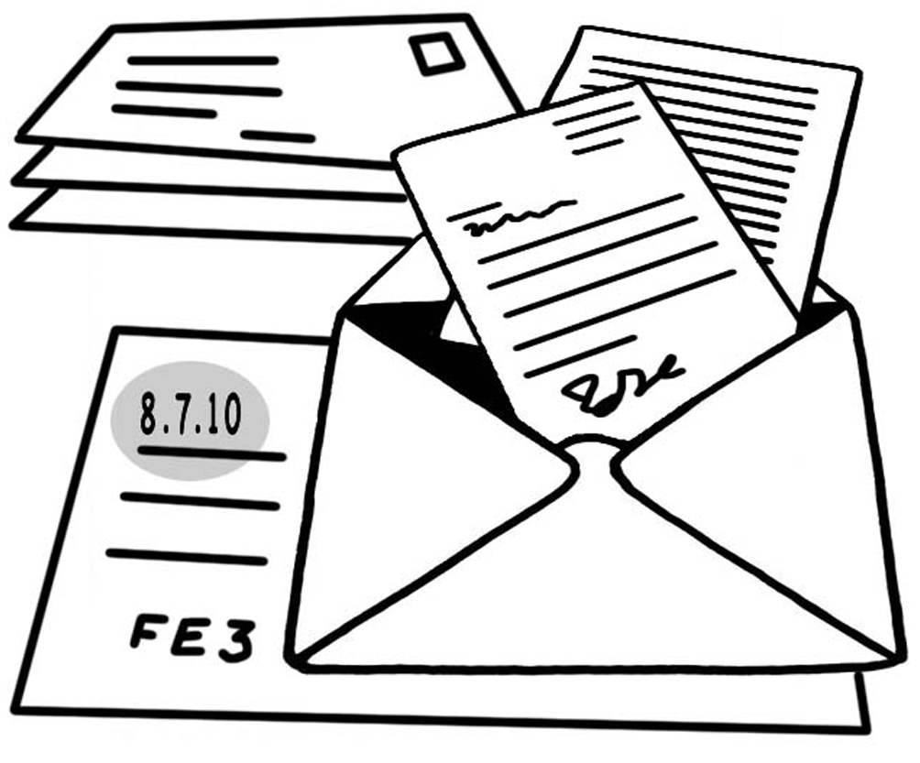Address

What they do


Comments
How helpful
Database
Organisations working for people with Learning Disabilities
Name of
Organisation

Telephone | Fax | Minicom
e-mail

Helpful person
you know

Address

What they do

Comments
How helpful

