☺□ interviewed for:

Persons name:

? | ☺ | 😐 | ☹

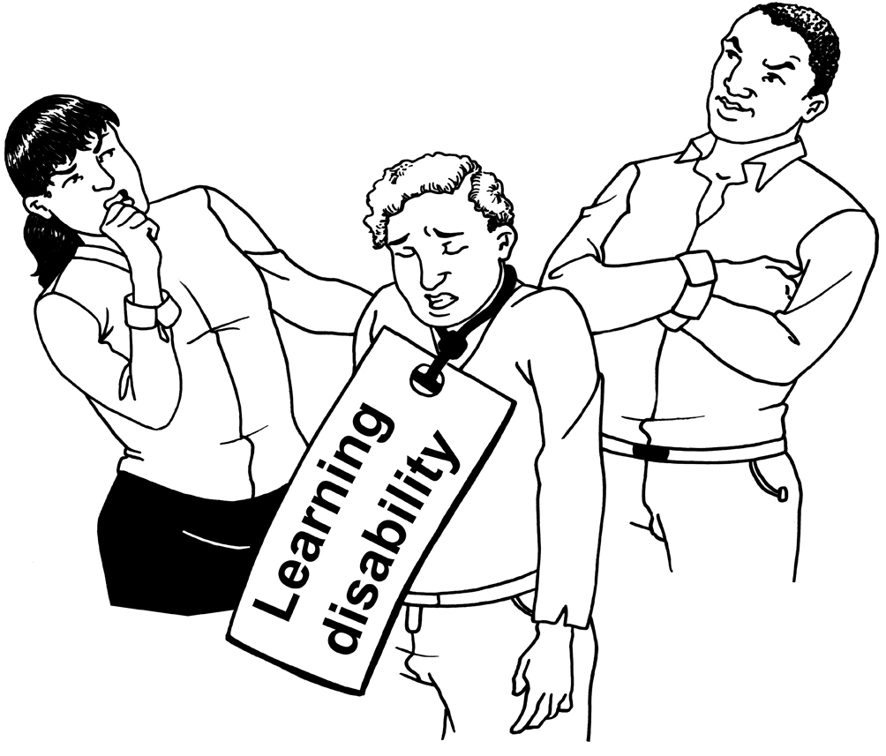
Is their attitude

respectful?

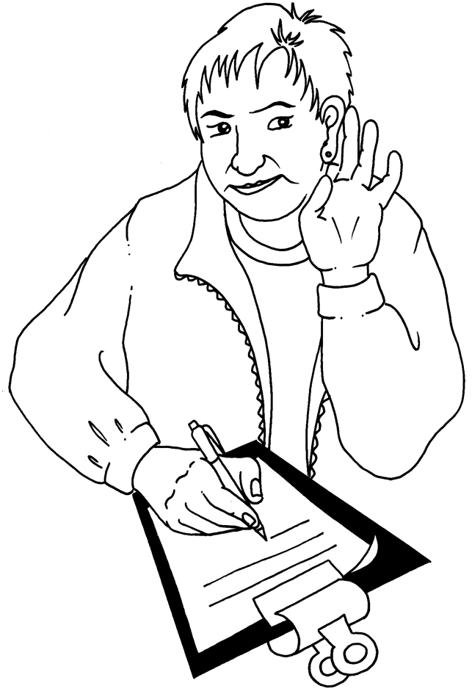
Do they listen well?

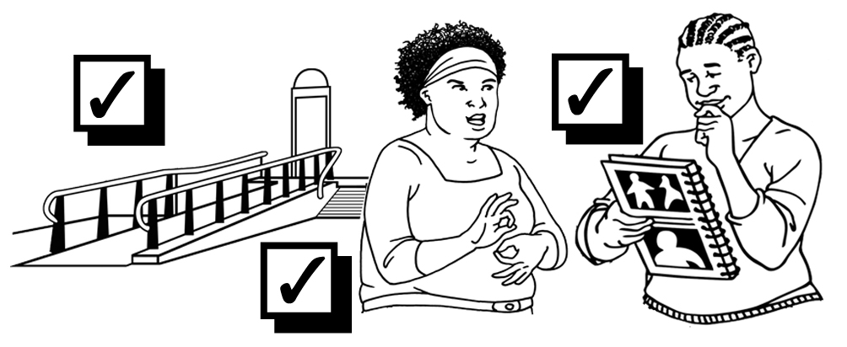
Do they know about different
kinds of
access?
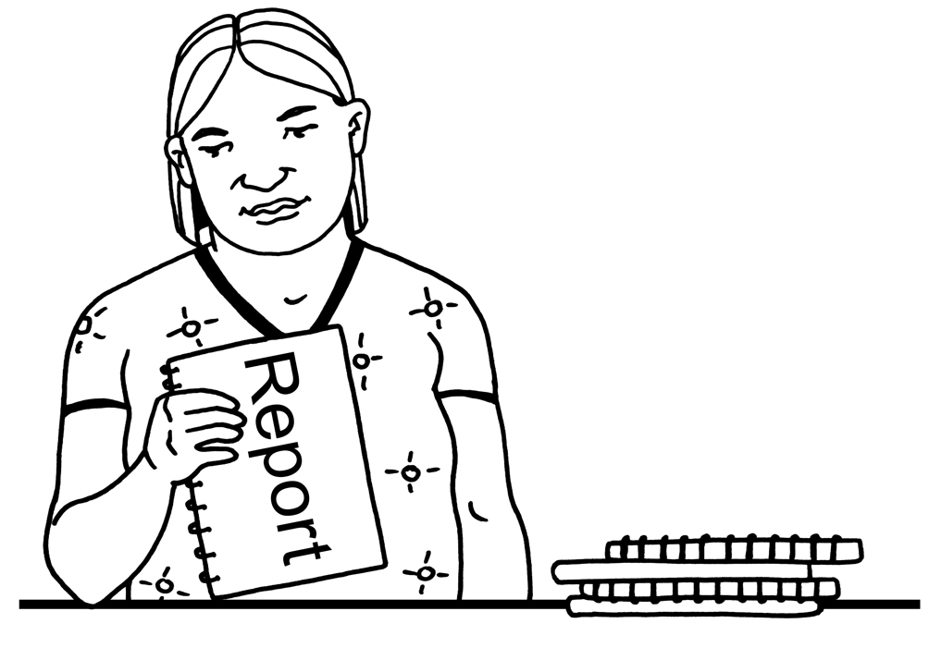
Have they
prepared
well?

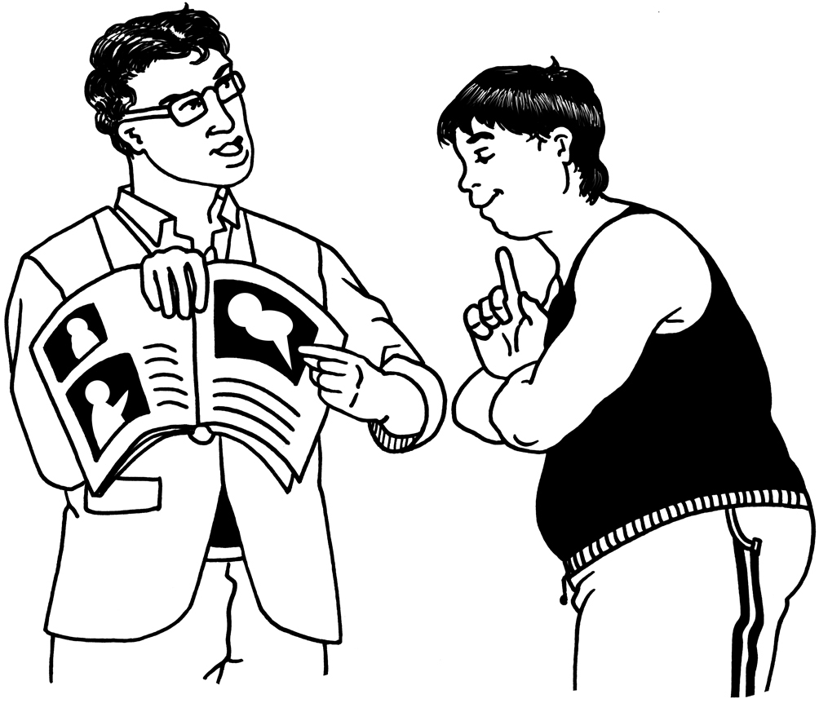
Would they give
good support?

Scores

Any other thoughts?

How to score: ☺ = 1 😐 = 1/2 ☹ = 0

