Job Interviewed for: | How to score: 
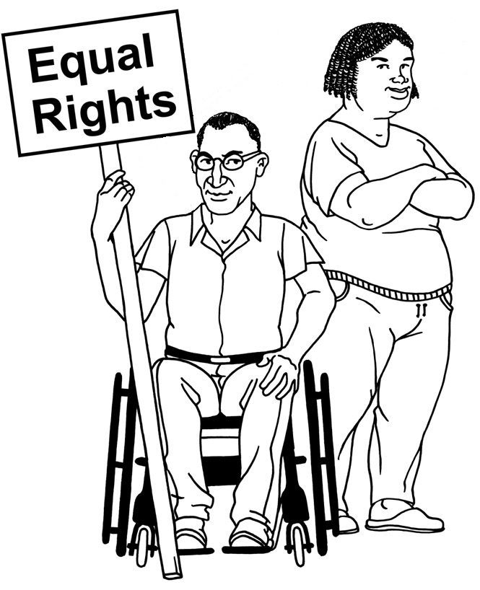  Candidate: | 1 | 2 | 3 | 4 | 5 | 6 | 7 | 8 | 9 | 10
Know rights
and issues of
people with L/D?

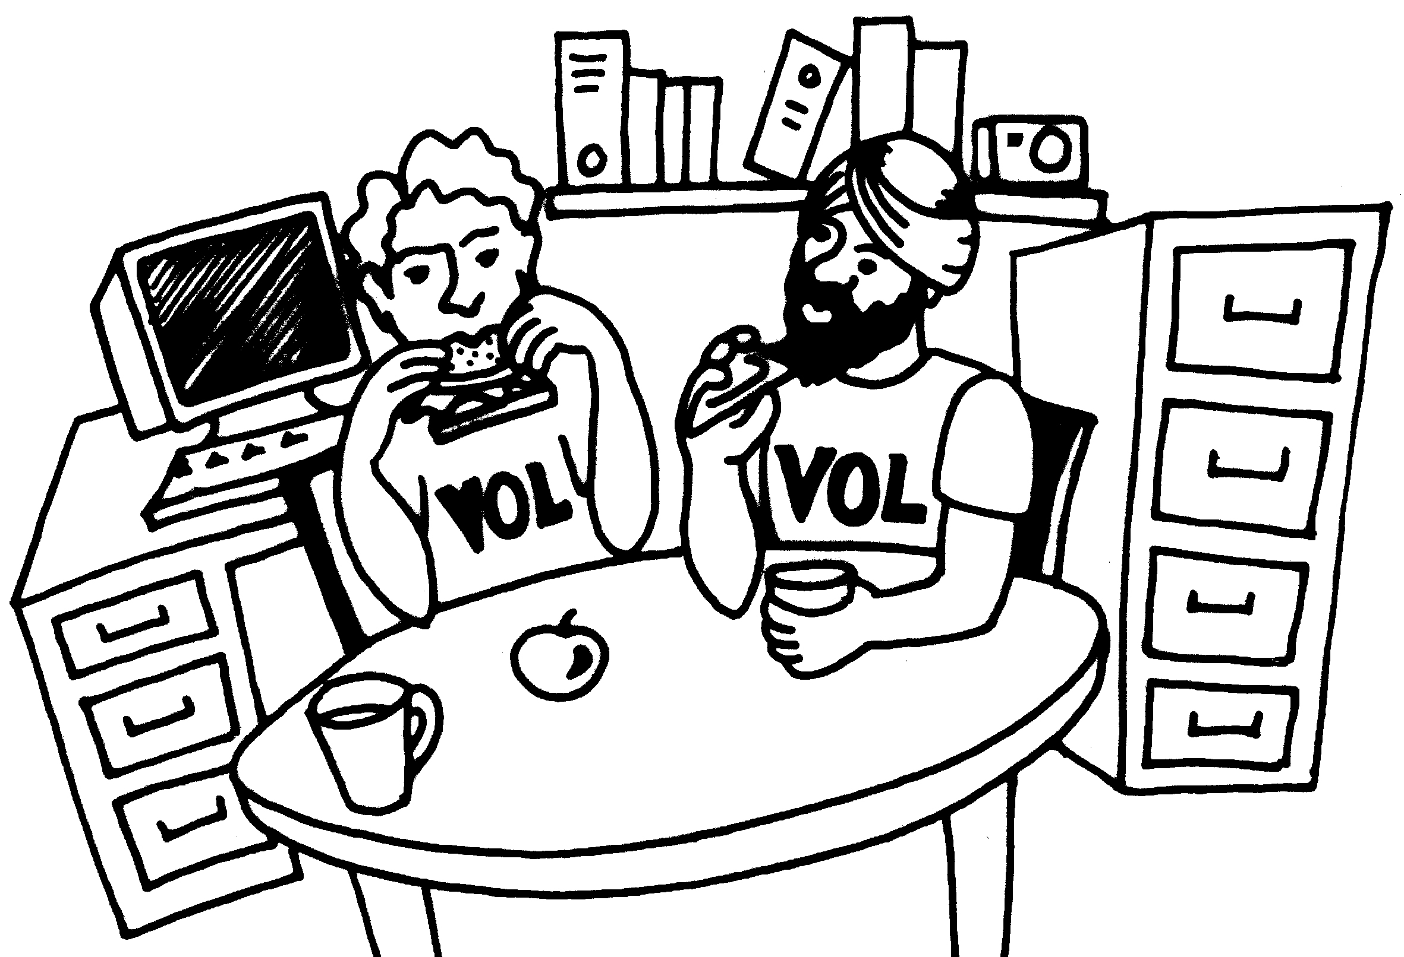
Work/volunteer

in a voluntary organisation?

Organisation
and planning
skills
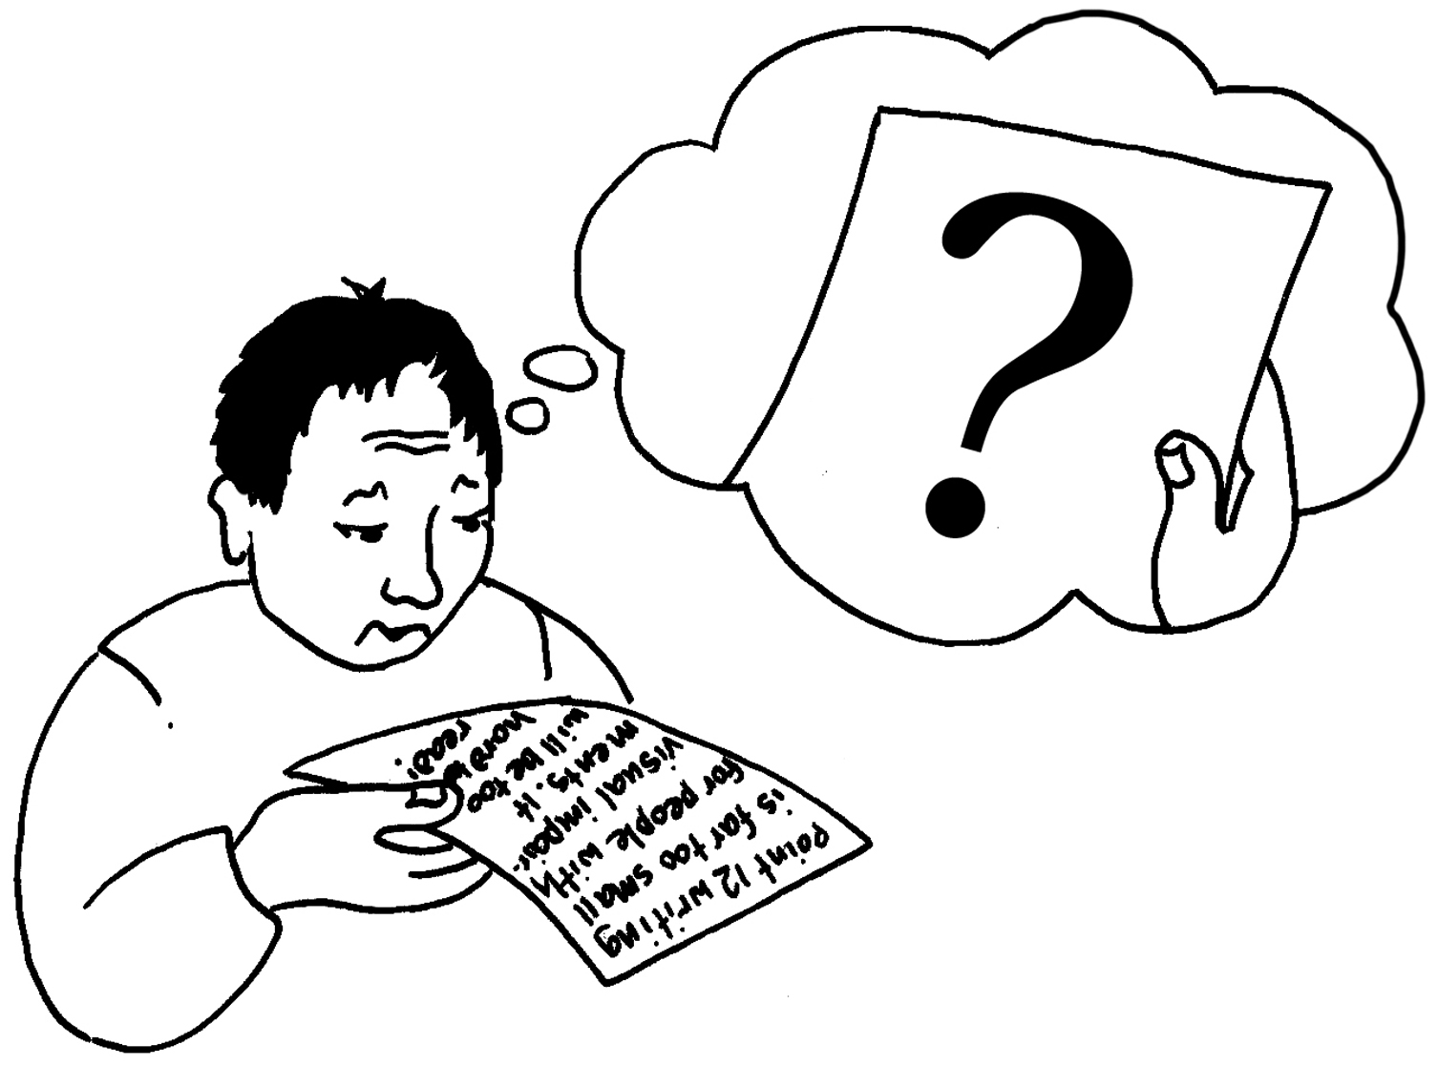
Understands
accessible
working?
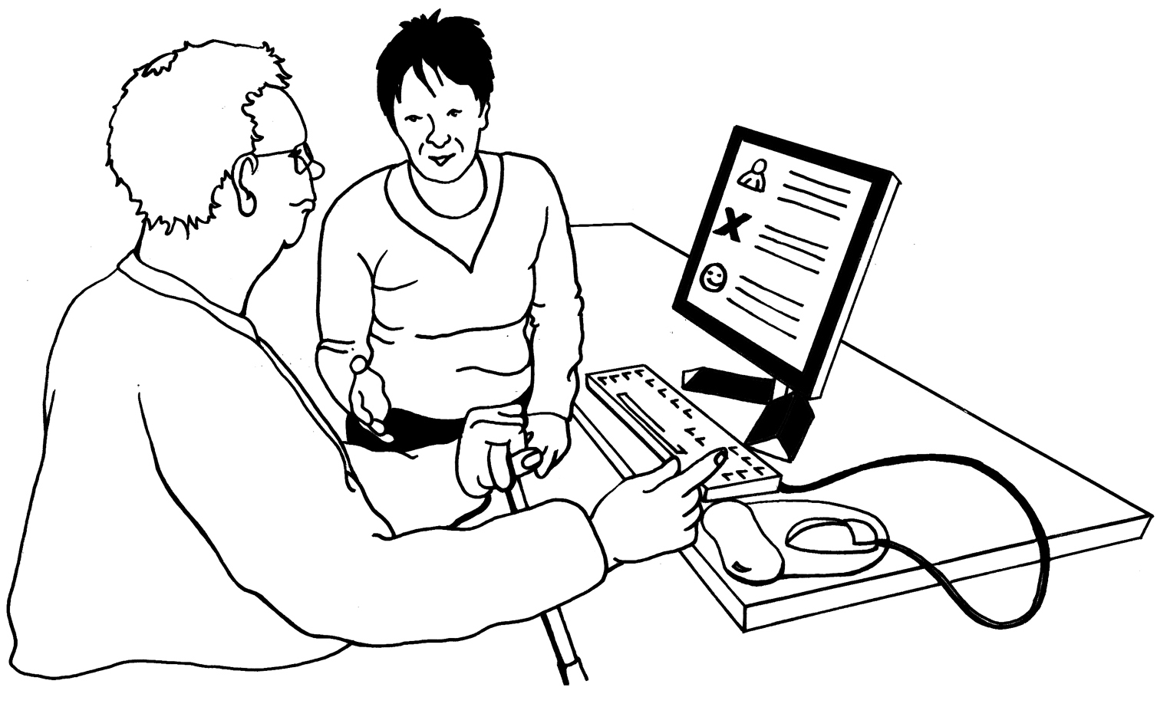
Can work
as a team?

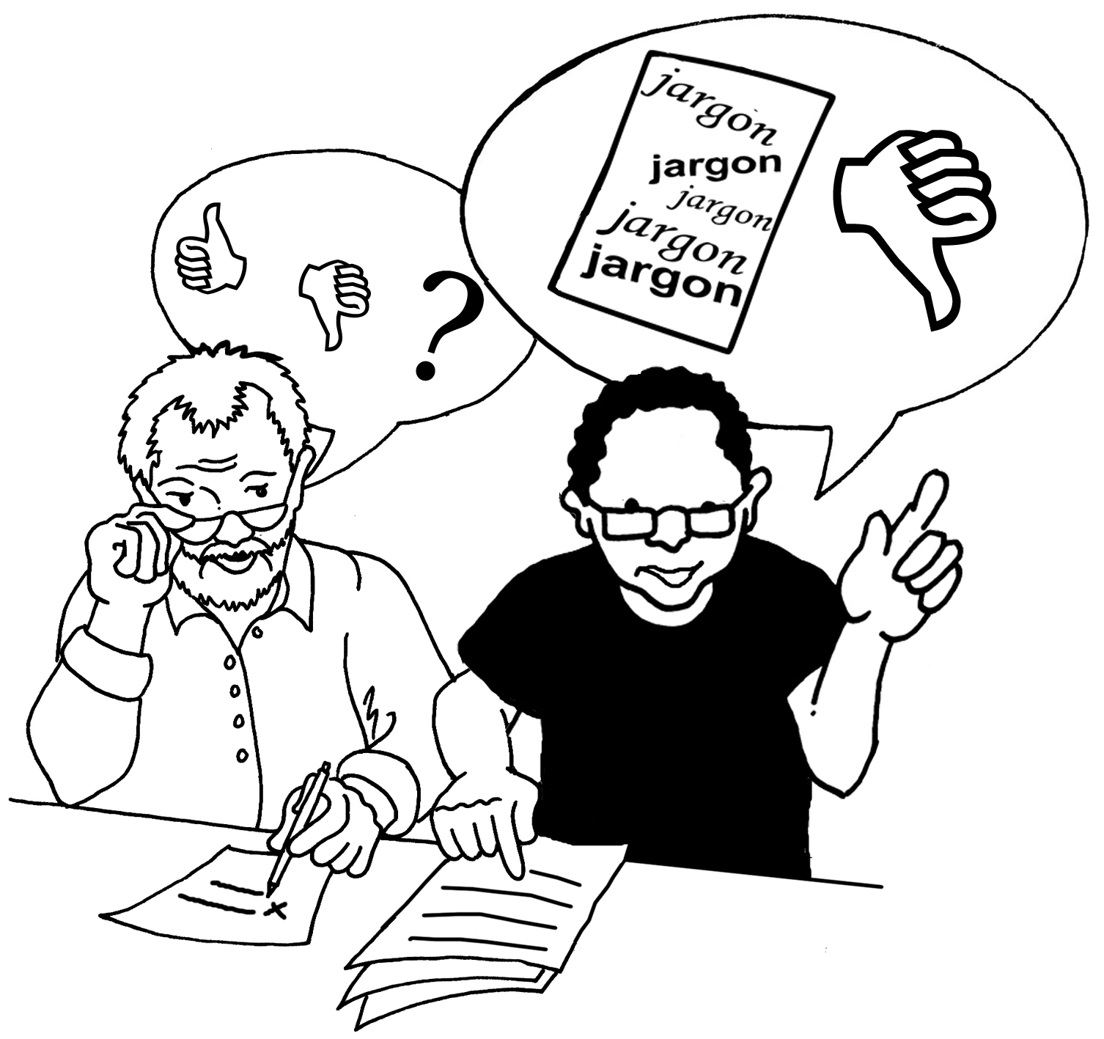
Would they give
good support?

Job specific skills

Any comments:

Scores

