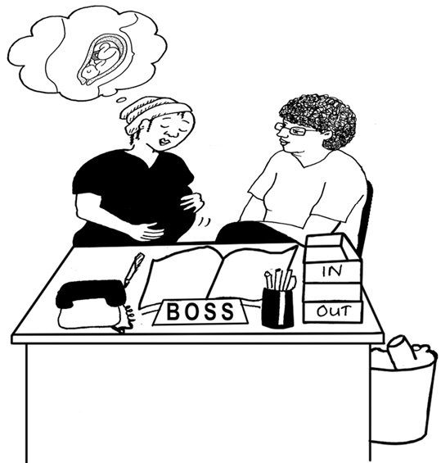
Maternity Leave

If you are pregnant, please let your line manager know as soon as possible. A meeting will be arranged with you to talk about your maternity rights and look at any special health and safety risks in your workplace.
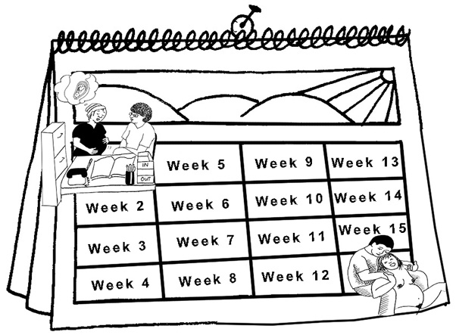

What you must do:

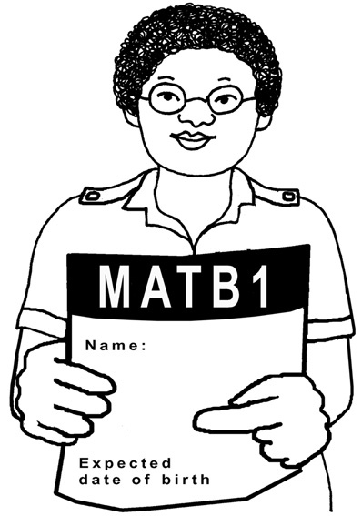
To qualify for maternity leave you must tell us by the end of the 15th week before the expected week of childbirth;

- that you are pregnant

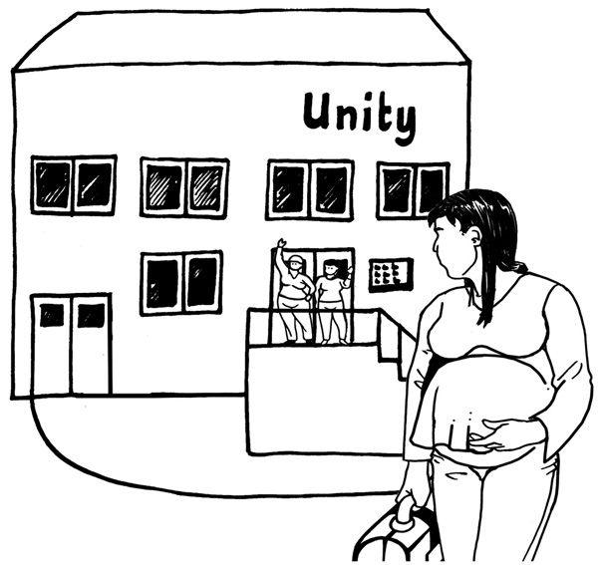
- when your baby is due, which will be written on a form - MAT B1 given to you by your doctor or midwife

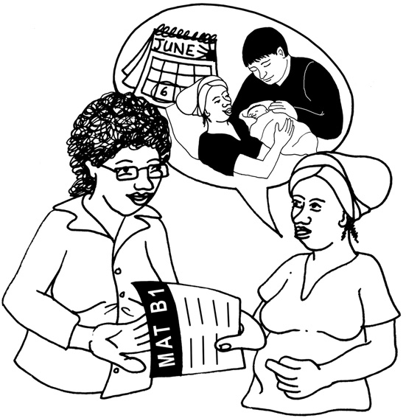
- the date you plan to start your maternity leave. You can change this date later as long as you give 28 days notice.

You have to give the authorised MAT B1 form to your line manager as soon as your doctor or midwife gives it to you.


What we will do:

We will write to you within 28 days of you telling us when you expect to start your leave. We will assume that you will take all 52 weeks leave. If you wish to return earlier you must give us at least 8 weeks notice that you are coming back earlier or wish to change your return date.
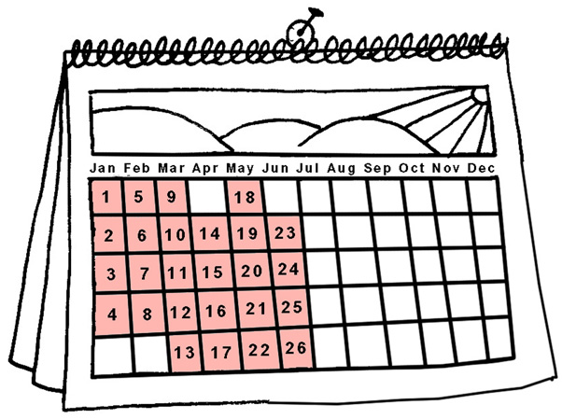

What leave you can take:

52 weeks Maternity Leave.
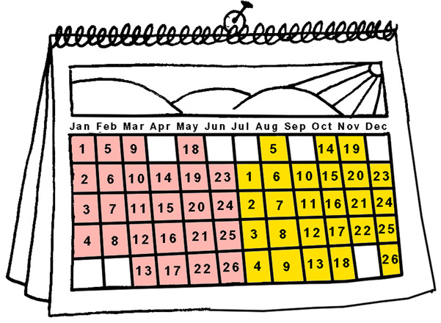
This is made up of 26 weeks Ordinary Maternity Leave (OML) and 26 weeks Additional Maternity Leave (AML). Leave can be taken up to eleven weeks before the expected date of childbirth.

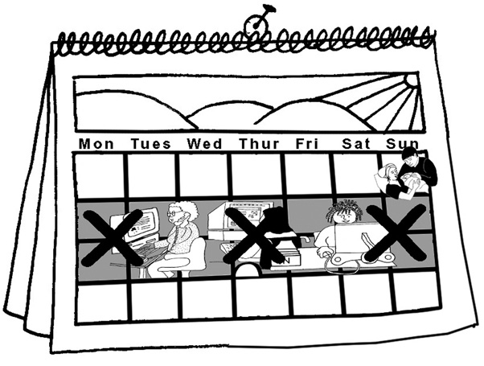
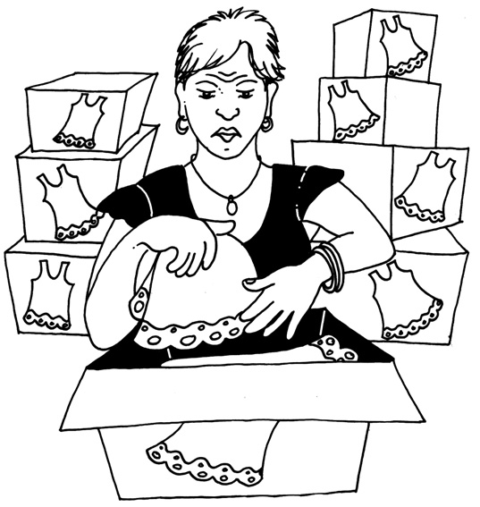
If you wish to take 26 weeks Additional Maternity Leave (AML), it starts on the day after your last day of Ordinary Maternity Leave.
= 4 weeks leave

You must take compulsory leave for two weeks after your baby is born or 4 weeks if you work in a factory.

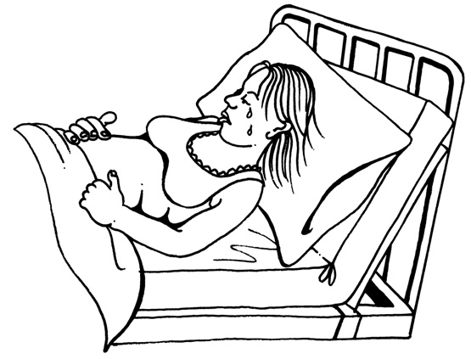
If things do not go right during pregnancy or birth, you still
have a right to the maternity
leave you originally asked for.

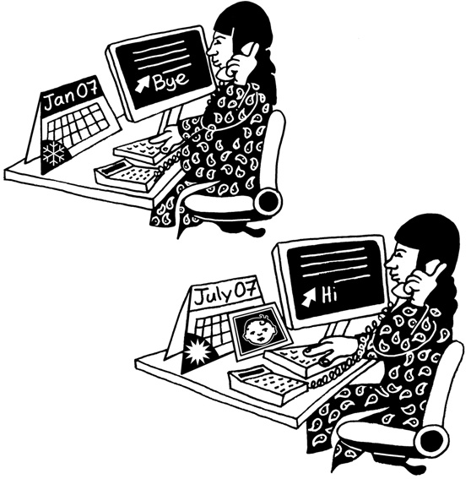
Coming back to work:

- After Ordinary Maternity Leave, you have the right to return to the same
job as when you left.

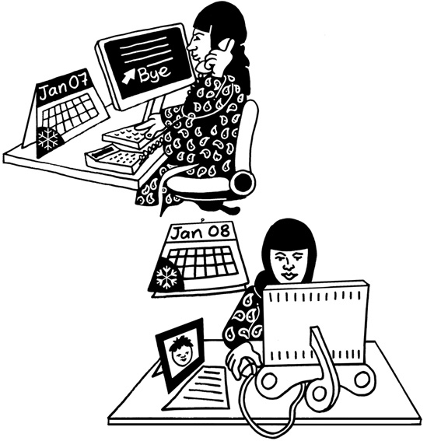
- After Additional Maternity Leave, you have the right to return to the job you had when you left,

or if this is not possible, to a similar job with pay and benefits at least as good as your original job.

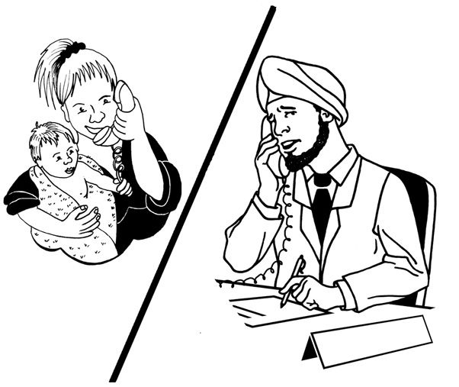

We will keep in touch with you during your Maternity leave in case there are any changes that affect your job.

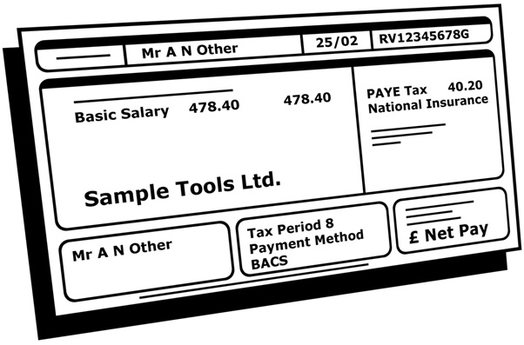

Maternity Pay

Statutory Maternity Pay (SMP) for 39 weeks if:

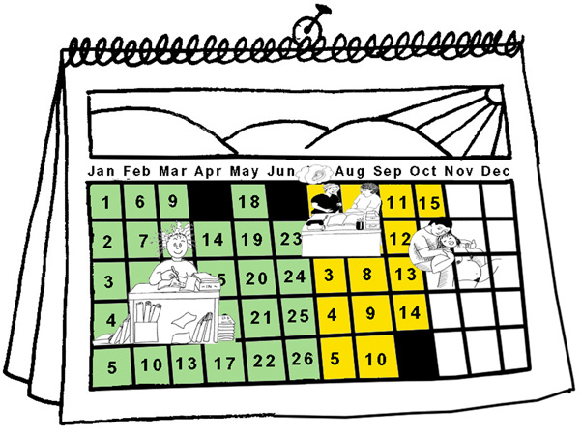
- you have been continuously employed for at least 26 weeks by the end of the 15th week before the expected week of the birth,

and
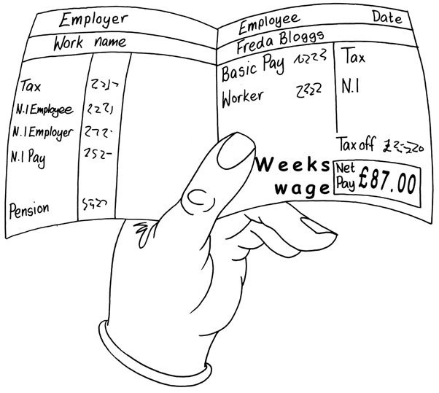

- your normal weekly earnings are at the minimum National Insurance lower earnings level.

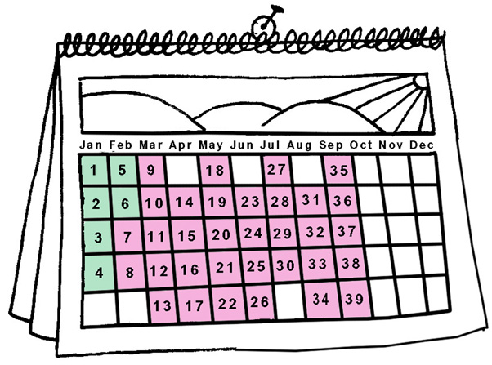
SMP will be paid up to 39 weeks.

The first 6 weeks are paid at 90% of full pay.

The next 33 weeks are paid at the current Statutory Maternity Pay level.

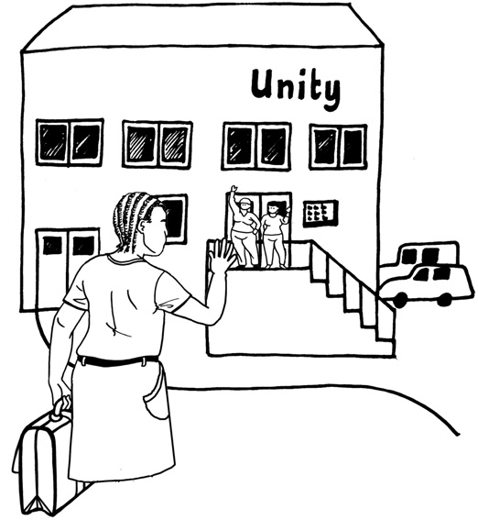
Other Rights

During your maternity leave you have the option to carry out up to 10 days work. These are known as ‘keeping in touch days’.

You only have to do this work if you want to and it does not affect your Statutory Maternity Pay.

Your employer will pay you if you choose to work for this time.
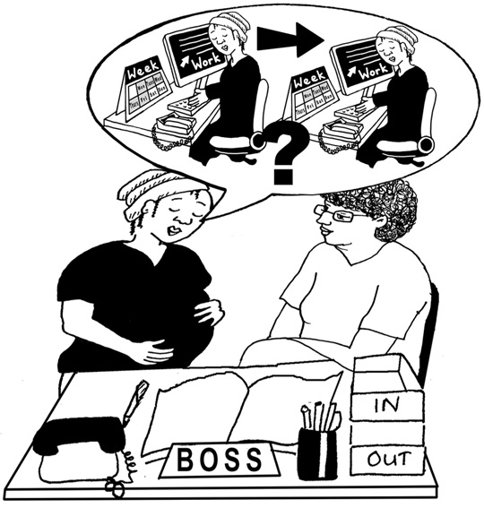

If you want to return to work on a part-time basis, we will consider your request sympathetically.
However there is no right to return on different terms and conditions from when you left.

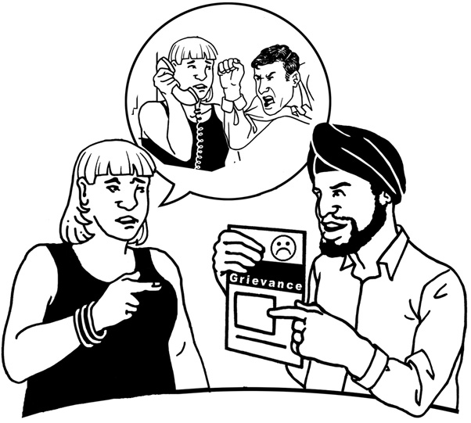

In order to ensure that managers apply the discretionary rules fairly, former employees will have the right to use the CHANGE Grievance Procedure to allow a review of any decision.

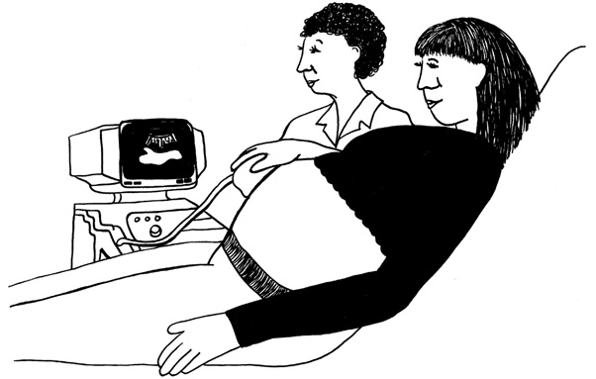
Time off for

Ante-natal Appointments
You are allowed paid time-off to attend ante-natal appointments connected with pregnancy. This will not count as sick leave.

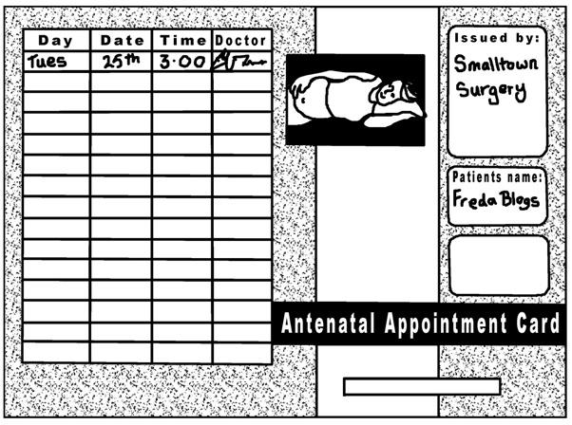

Your Line Manager will ask to see your official appointment card.

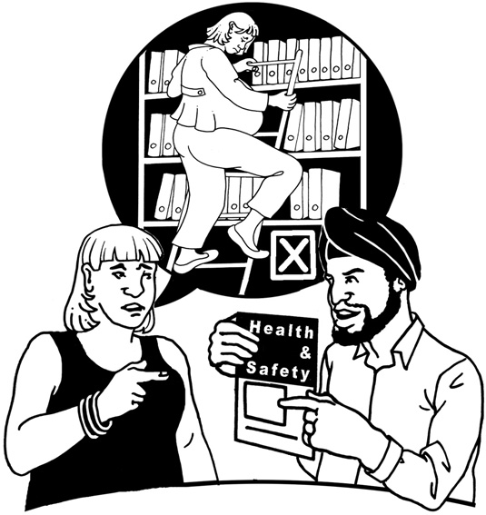

Personal Safety for Pregnant Employees

You should contact the Director who will arrange a meeting to discuss and assess the risk of injury in your particular working environment.

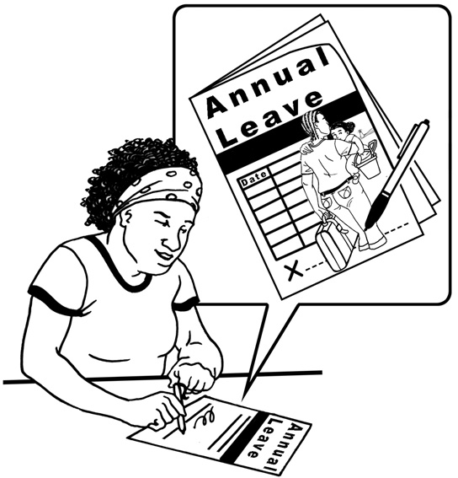

Benefits

Annual leave builds up as normal whilst you are on maternity leave.

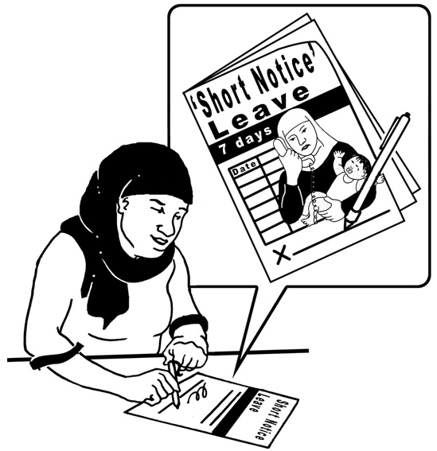
Up to 1 working week (the same number of days a week you normally work) of annual leave may be saved, to be taken at short notice, following your return to work. This may be called Short Notice Leave or Parental Leave.

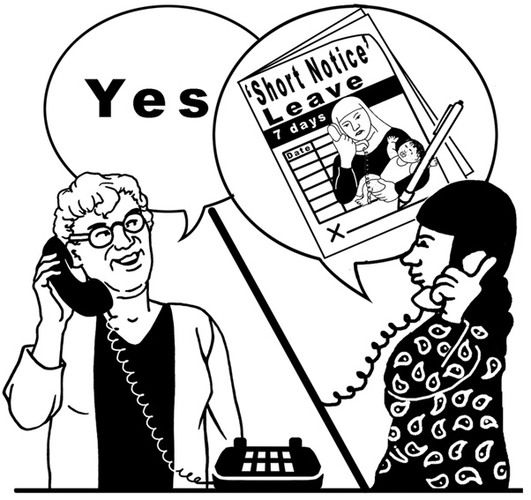

Your line manager will still need to approve ‘Short Notice or days you are allowed to build up or carry over.

Talk to your Line Manager if you need more information.

