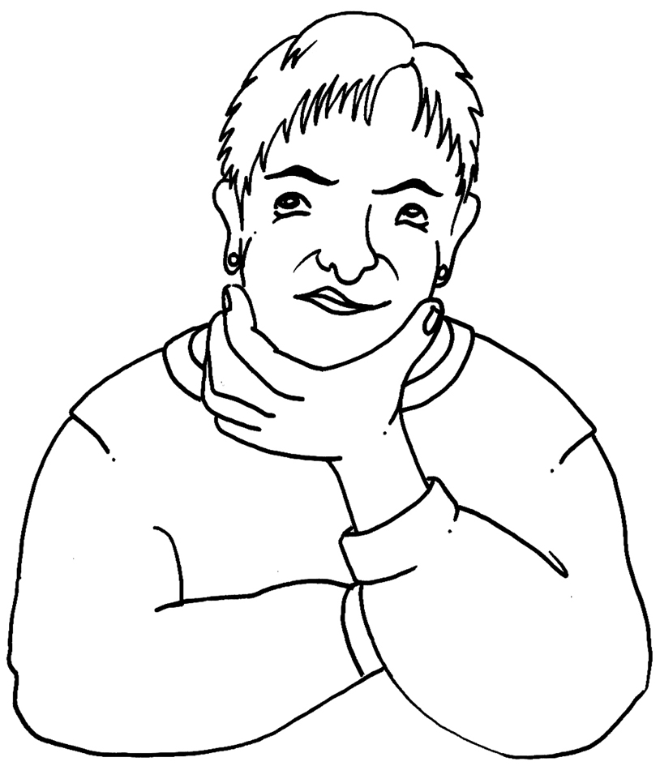  Name:  Time to Think  This is a chance to think about what your job is  and how YOU feel you are doing. | Job Title: | Notes

What are the main things I have to do in my job?

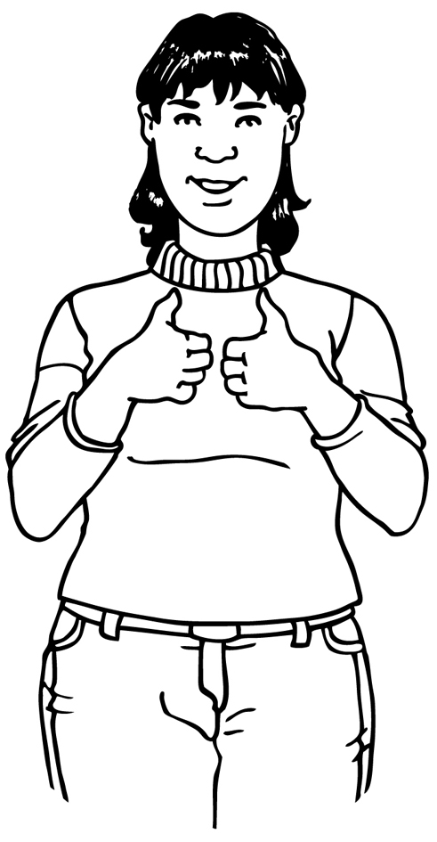
What parts of my job am I
good at?

What parts of my job do I find hard?
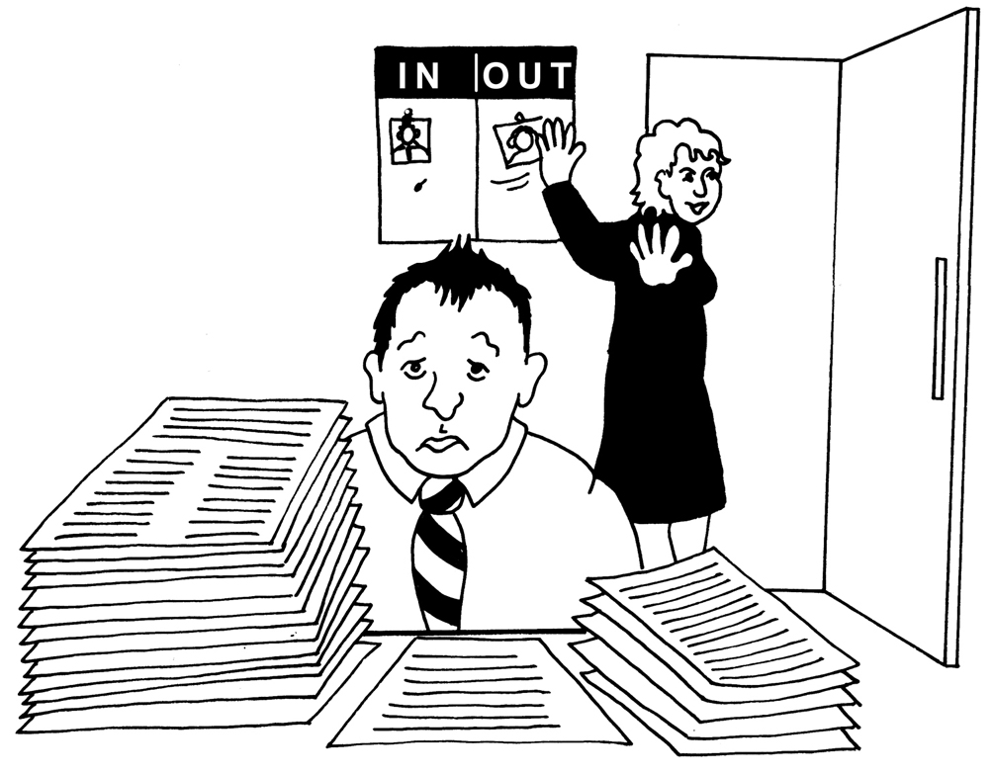

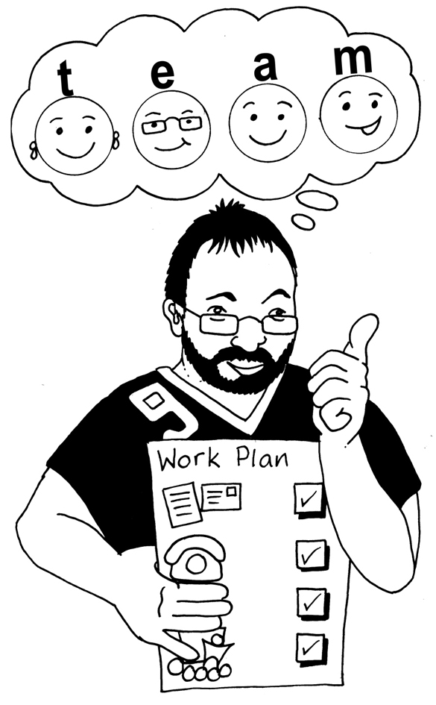
What could I do to make my
work
better?


Date filled in:

