

Staff Agreement

Staff member: ______________________

Supervisor: ________________________

Date: _____________________________

What we discussed:
Things that your employer is worried about:


How staff member feels about this:



What we will agree to do to sort things out:
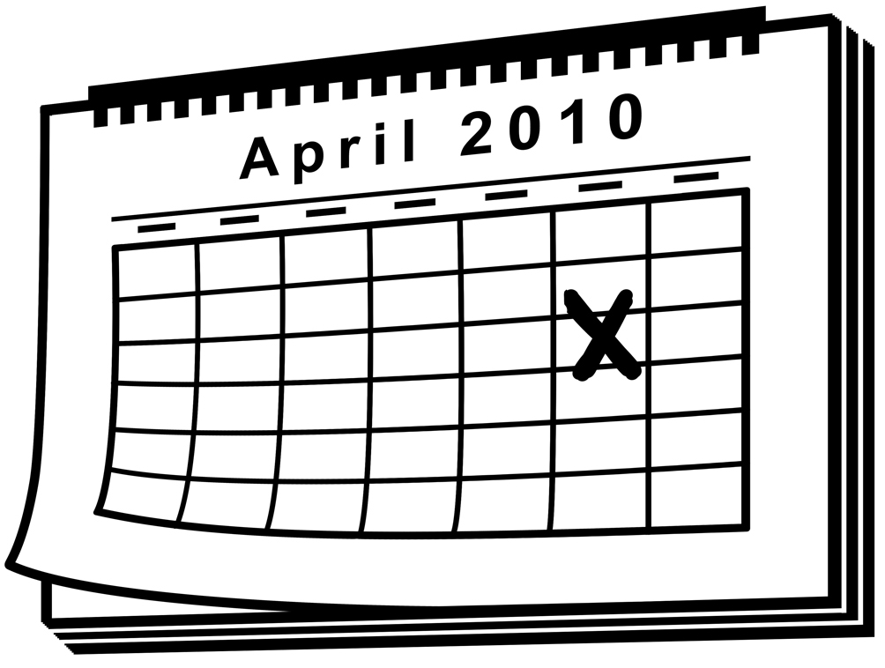 | How long we will give staff to show improvement?
What staff member will do.
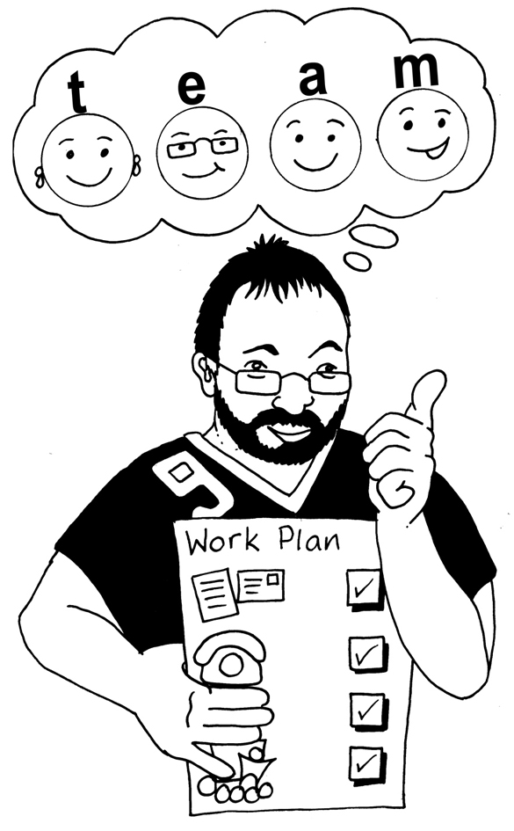

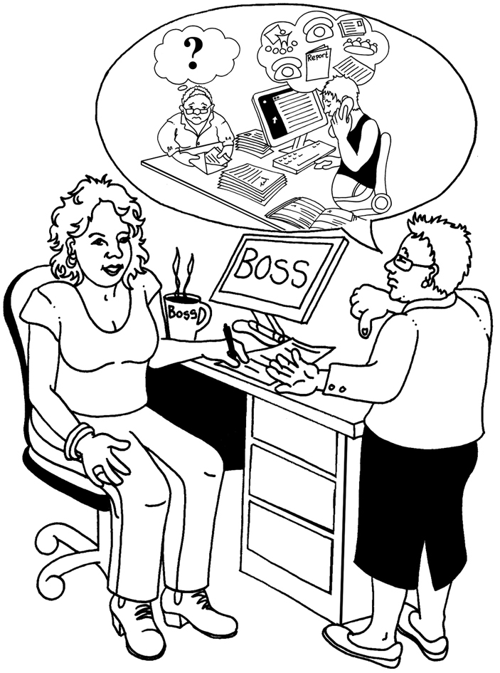
What support your employer will give.

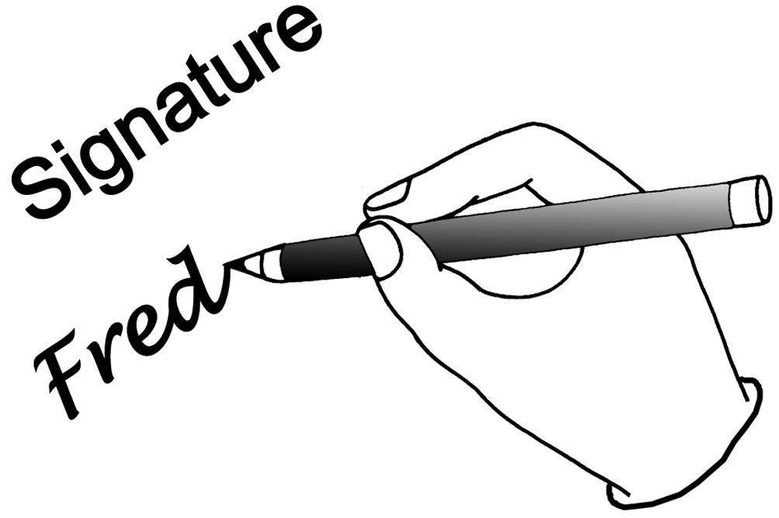  Signed and agreed by: | Staff member: | Supervisor:
Next Meeting:

