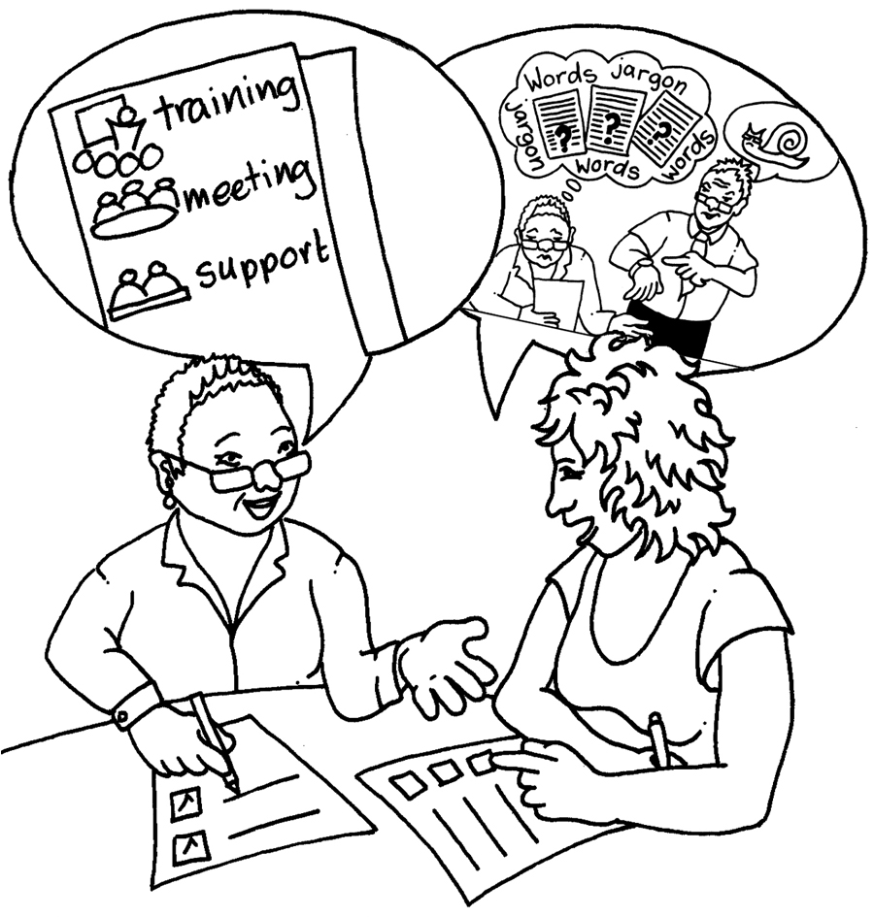

Supervision notes:

Area of work: ___________________________

Date we met: ___________________________

Workers name:

How we are feeling about work:
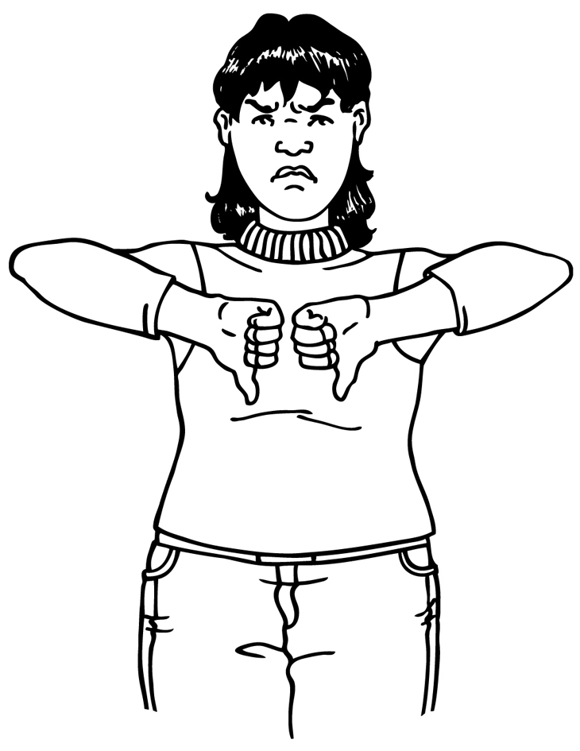
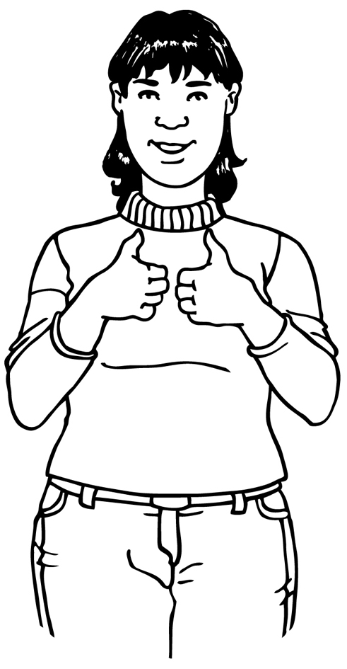

What have you been doing:
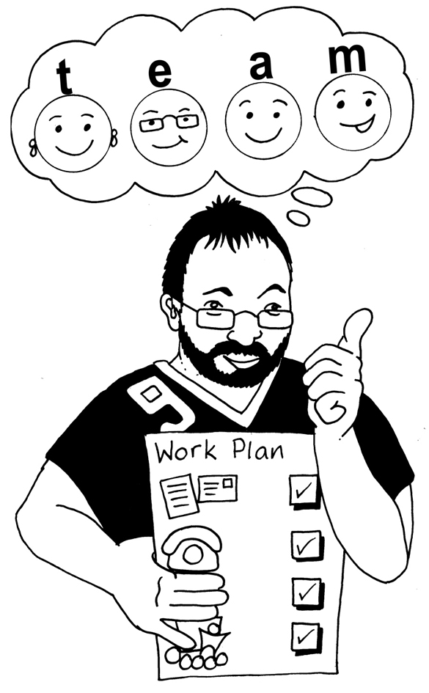

What you need to do next:

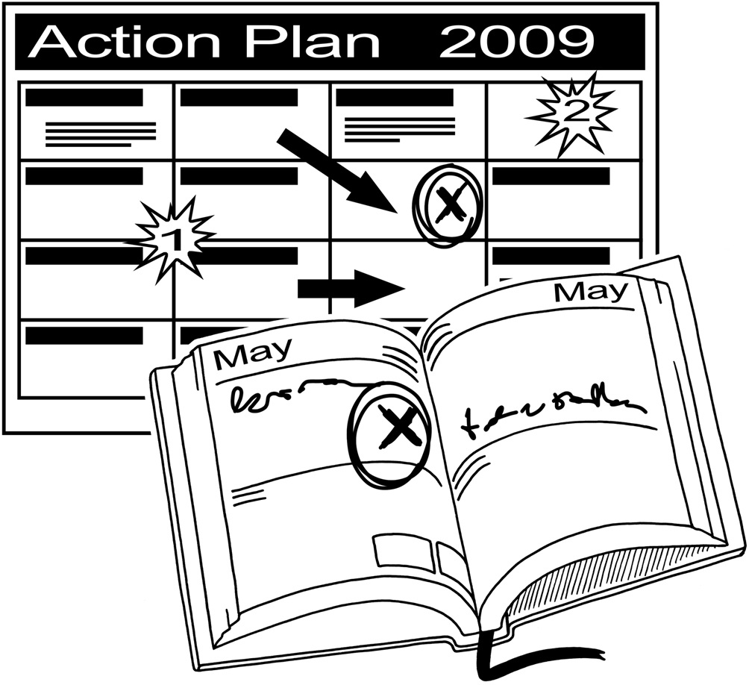

Any other things:


Action Plan:
Things that need to be done | Do by? |  | Done
 |  |  | ❑
 |  |  | ❑
 |  |  | ❑
 |  |  | ❑
 |  |  | ❑
 |  |  | ❑
 |  |  | ❑
Signed by:
Supervised by:
Next Supervision:

