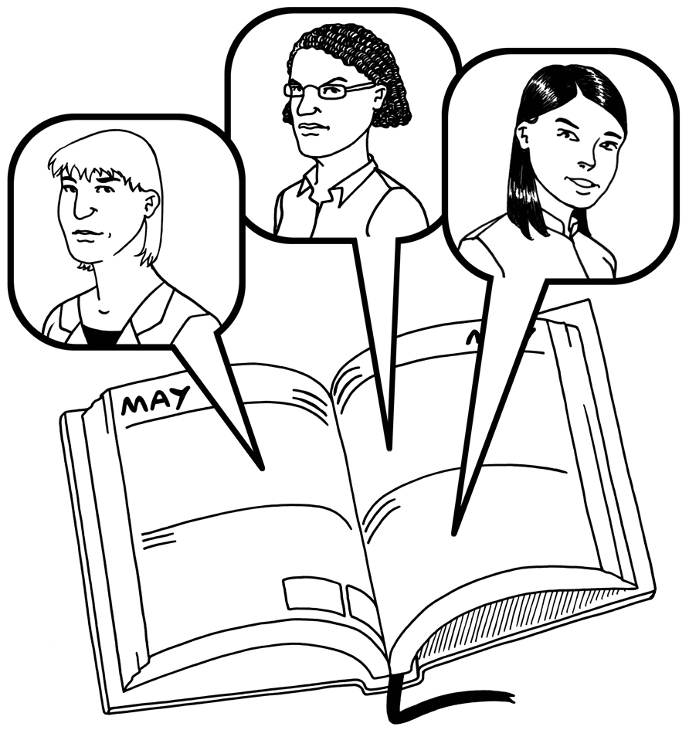

Team Planning

Area of work: ___________________________

Date we met: ___________________________

Workers names:

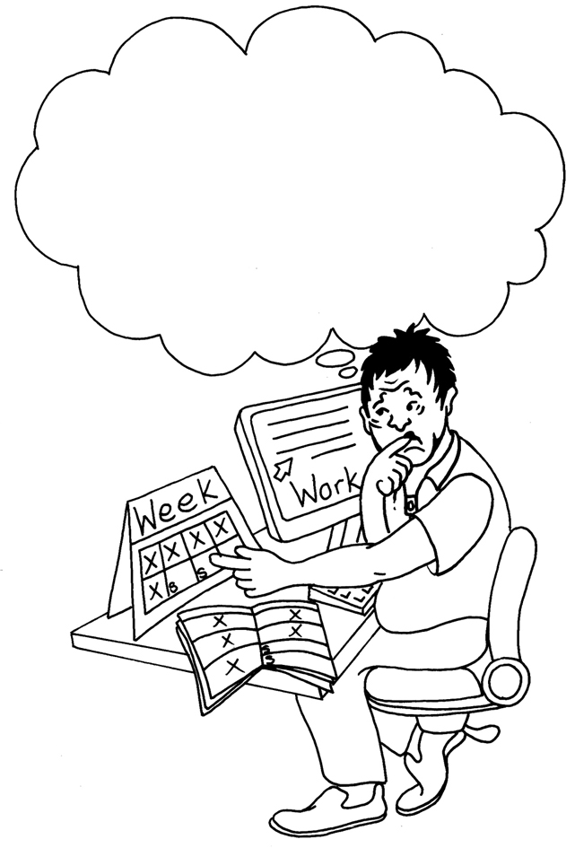
How we are feeling about work:

What we have been doing:
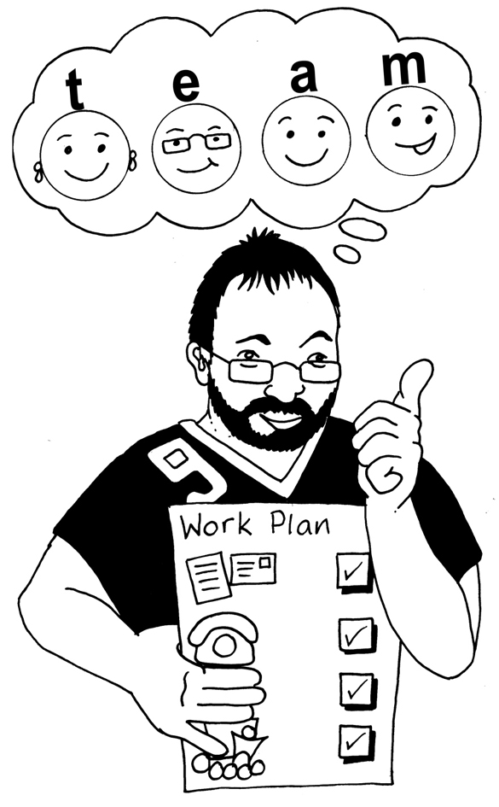

What we need to do next:

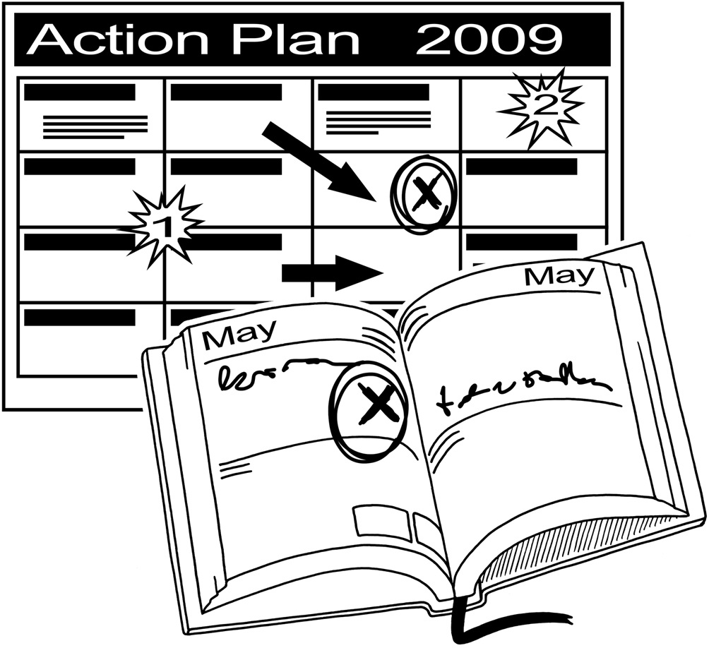

Action Plan: | Do by:
Things that need to be done | Who will do it? | Done
 |  | ❑
 |  | ❑
 |  | ❑
 |  | ❑
 |  | ❑
 |  | ❑
 |  | ❑
 |  | ❑
 |  | ❑
 |  | ❑
 |  | ❑
Any other things:


