Telephone messages
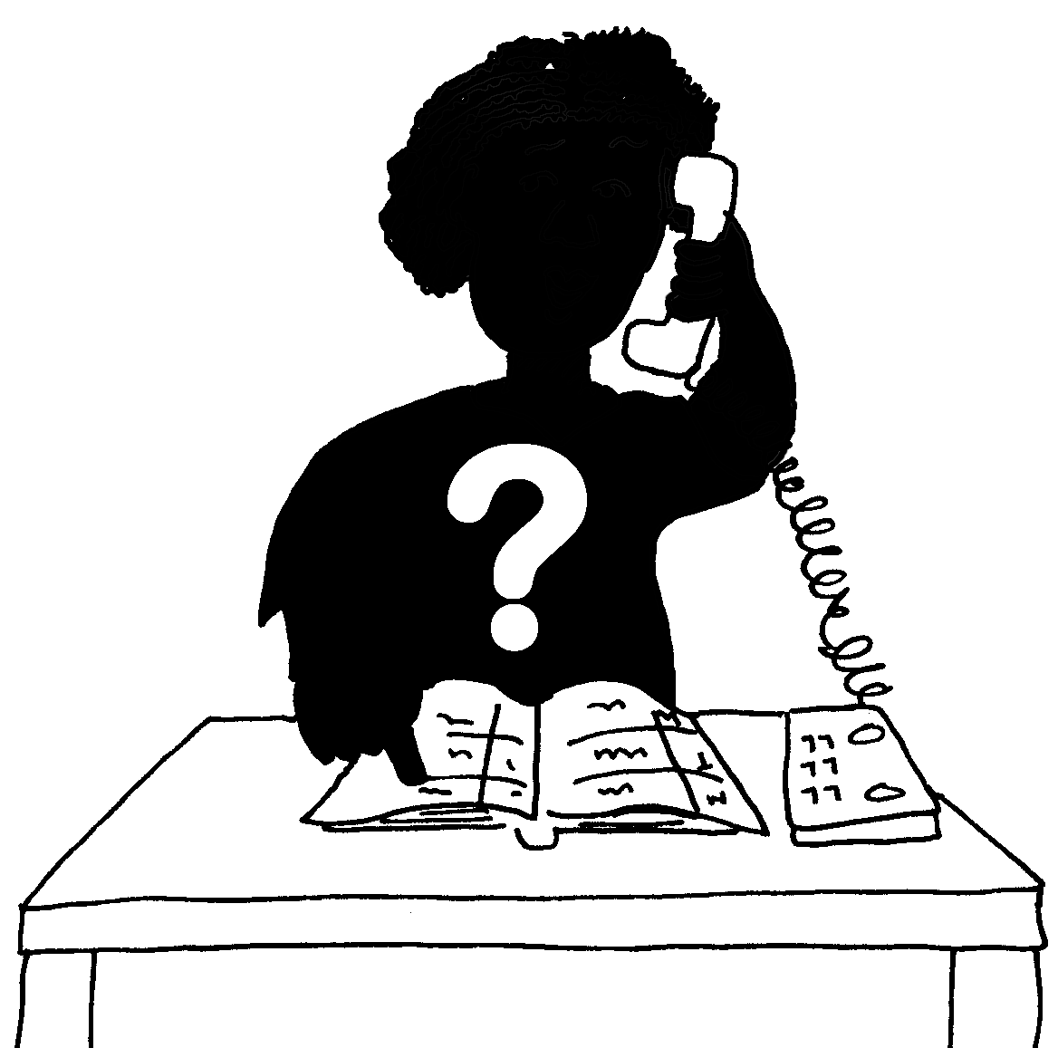  What is  your  name? | Name:  Job Title:
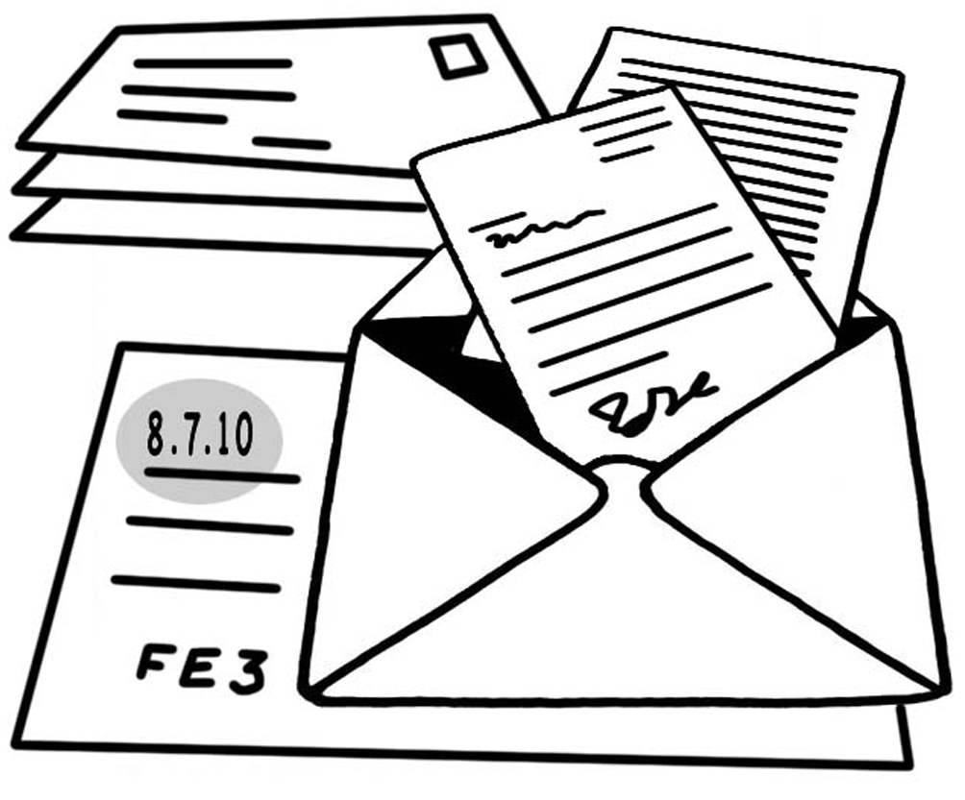
Where
do you
work
or live?
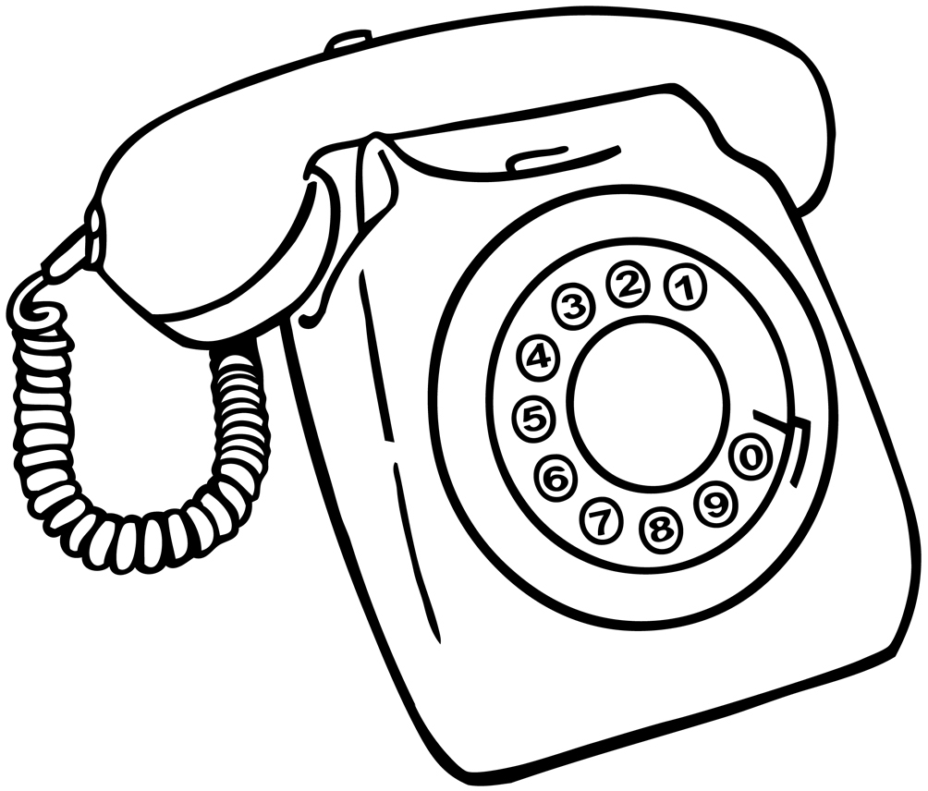
Telephone

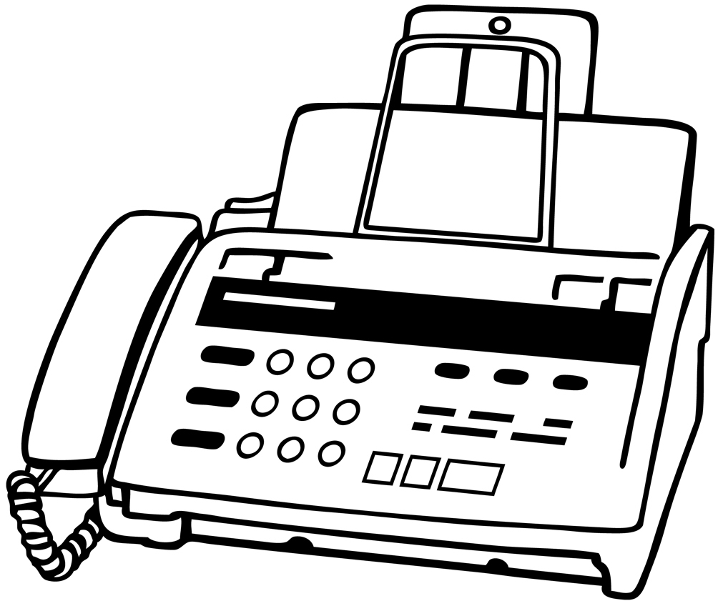
Fax

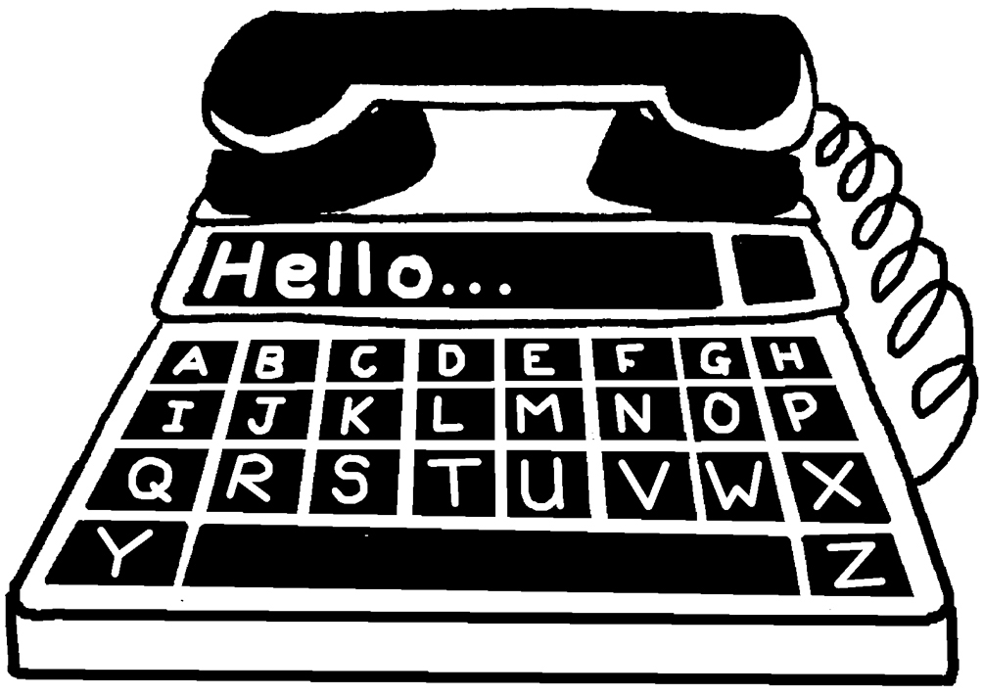
Minicom

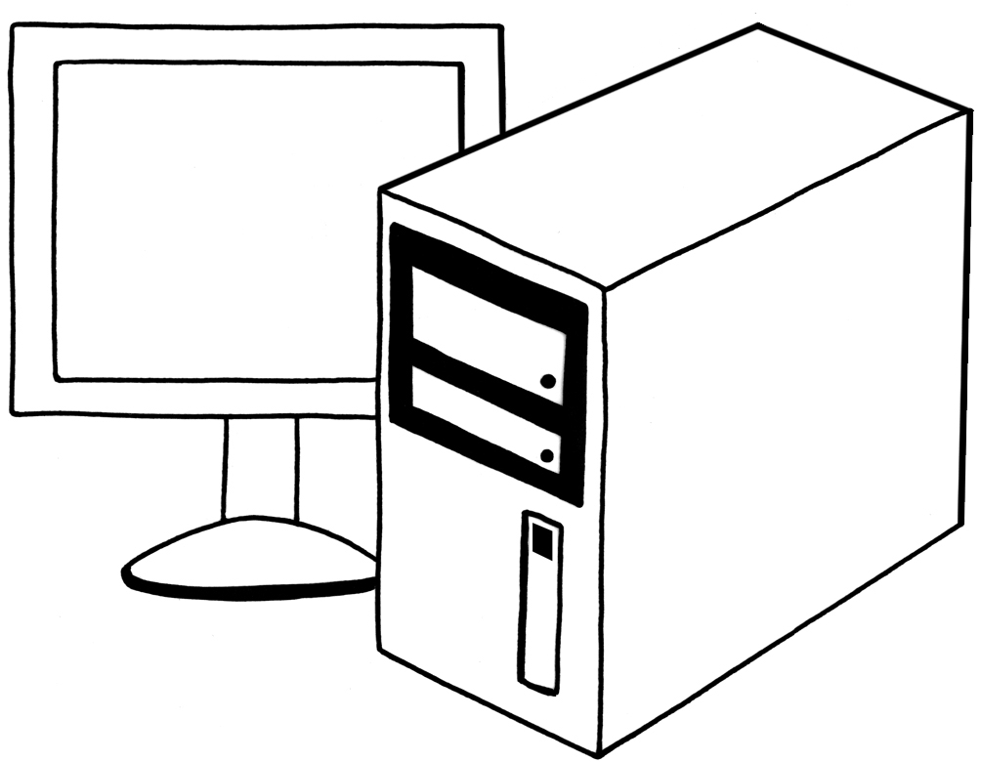
e-mail

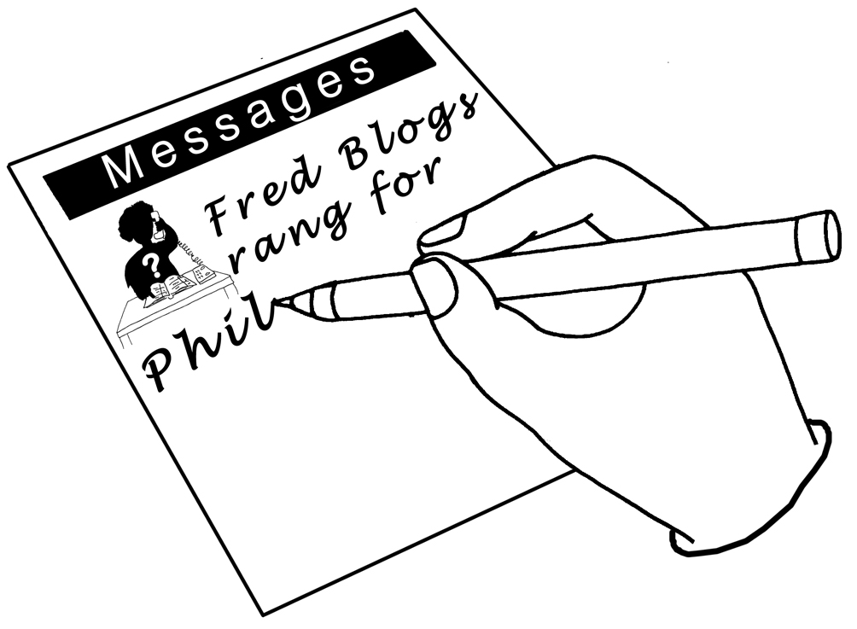
What is the call about?

Date of call?
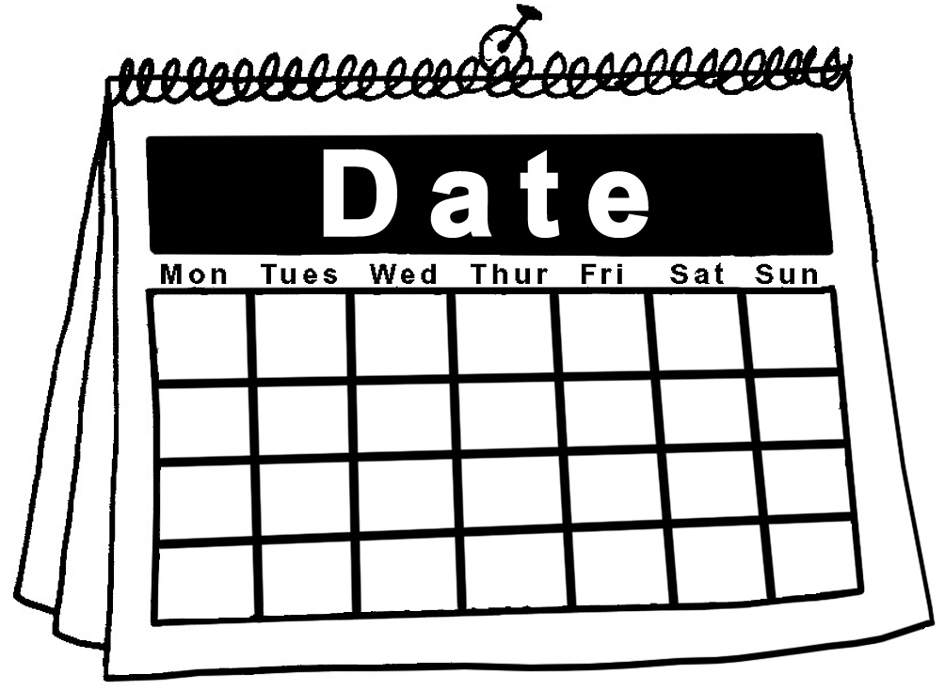

Telephone messages
What is  your  name? | Name:  Job Title:
Where
do you
work
or live?
Telephone

Fax

Minicom

e-mail

What is the call about?

Date of call?

