Messages
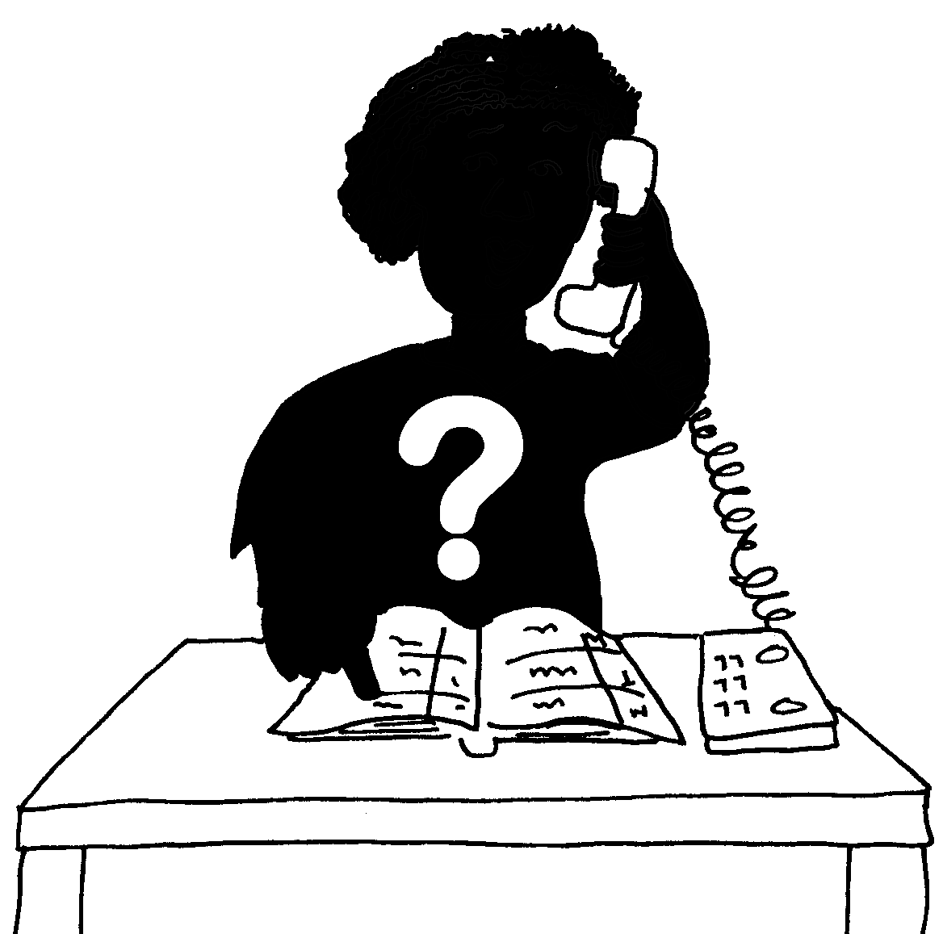
What is
your
name?
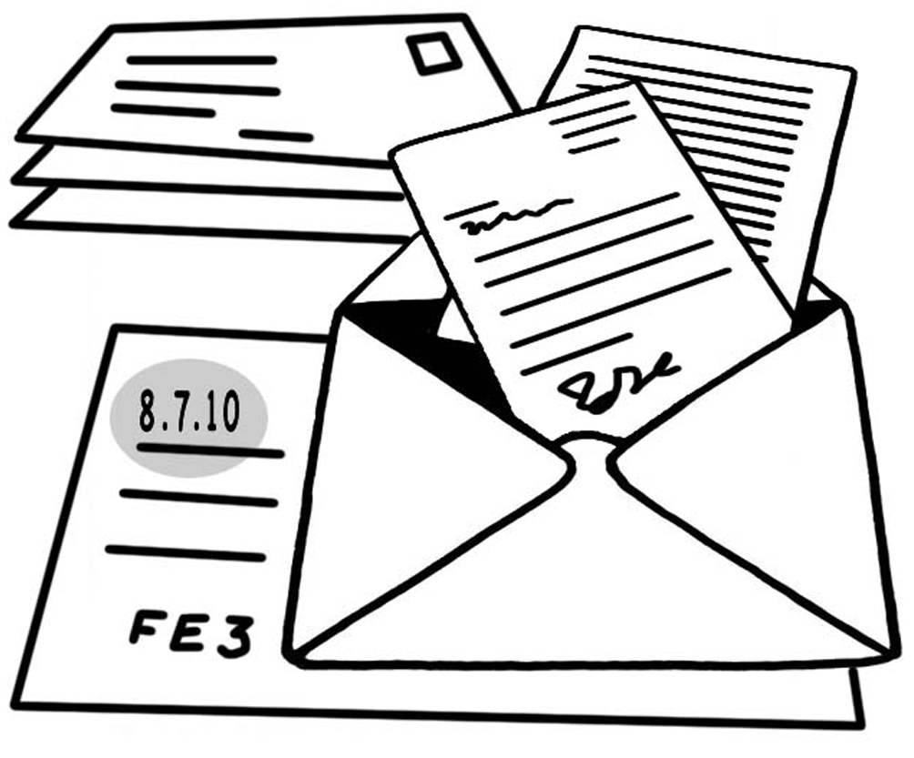
Where
do you
work
or live?
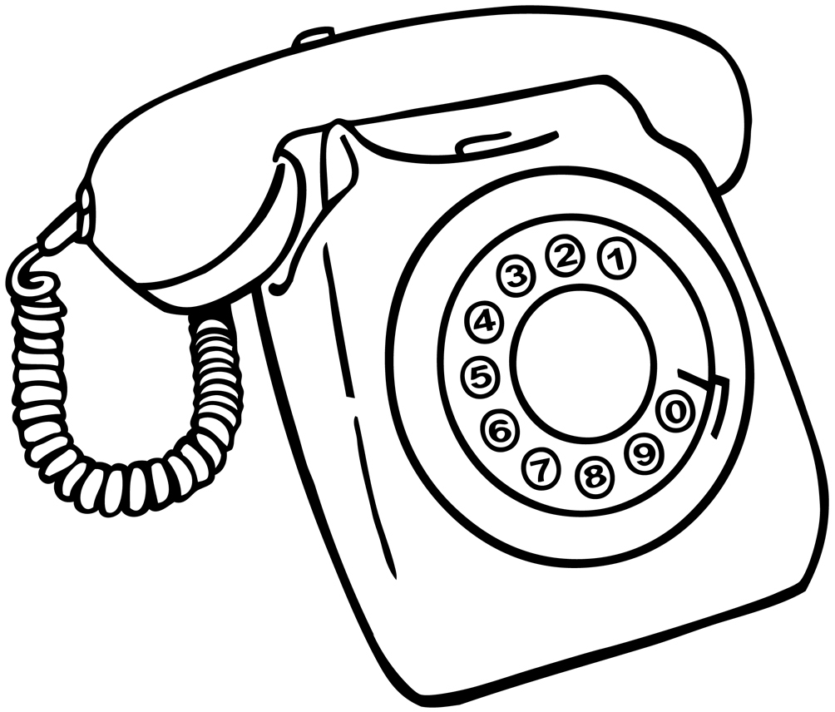
Telephone

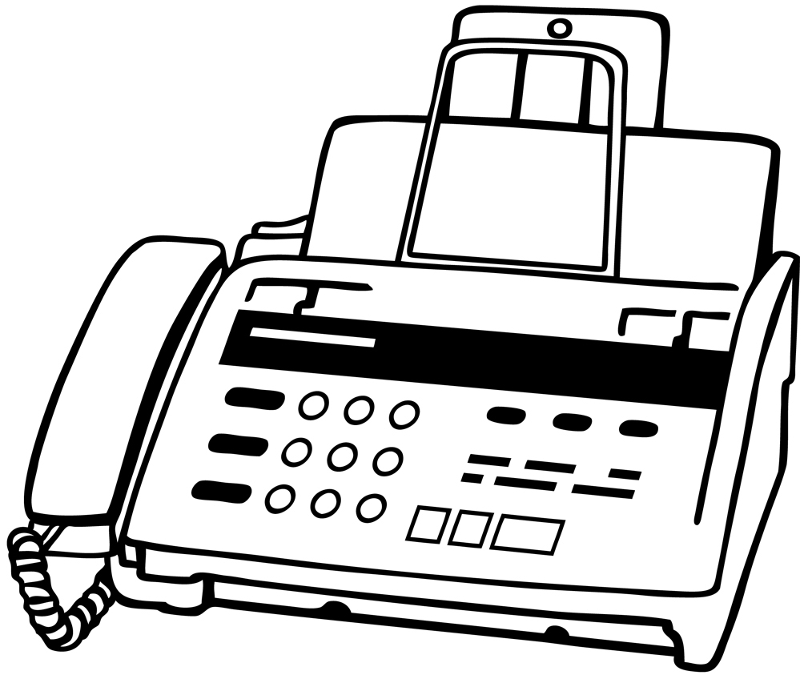
Fax

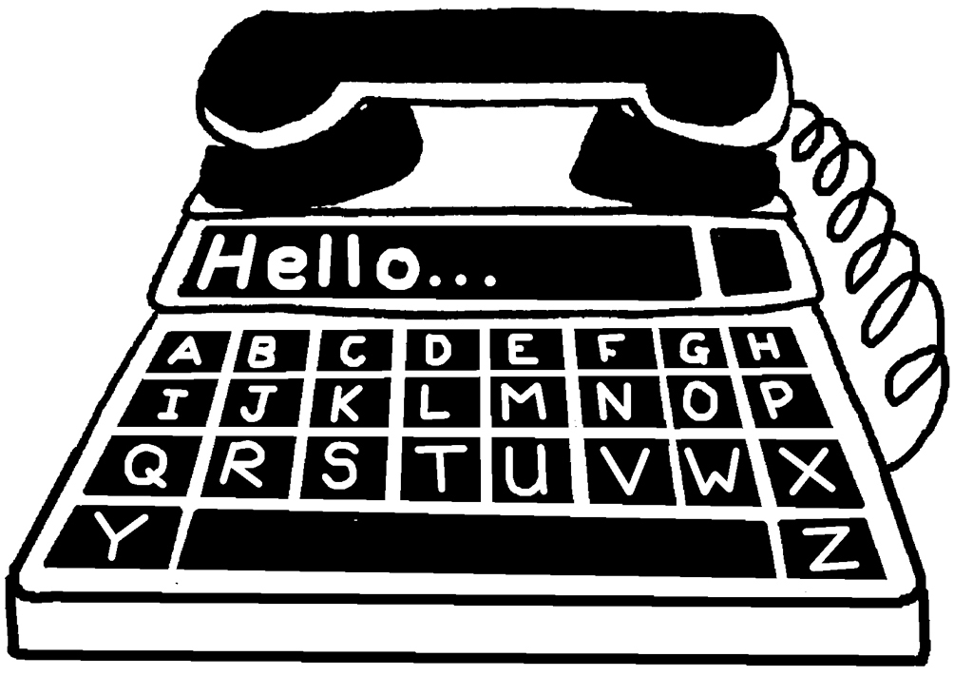
Minicom

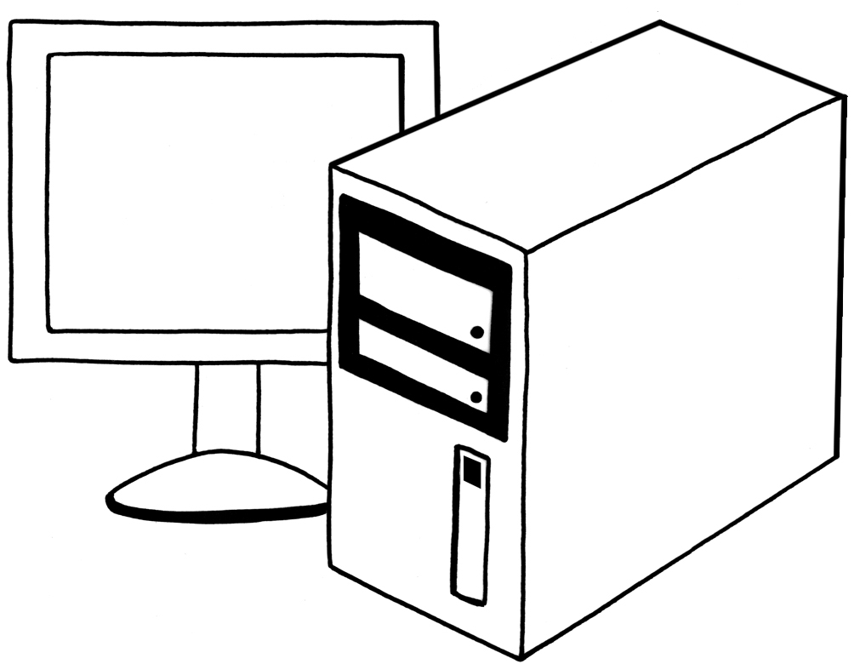
e-mail

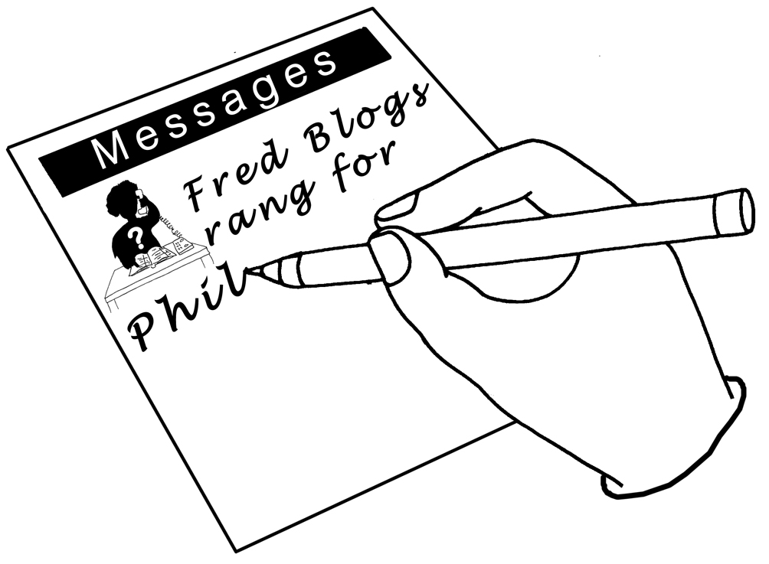
What is the call about?

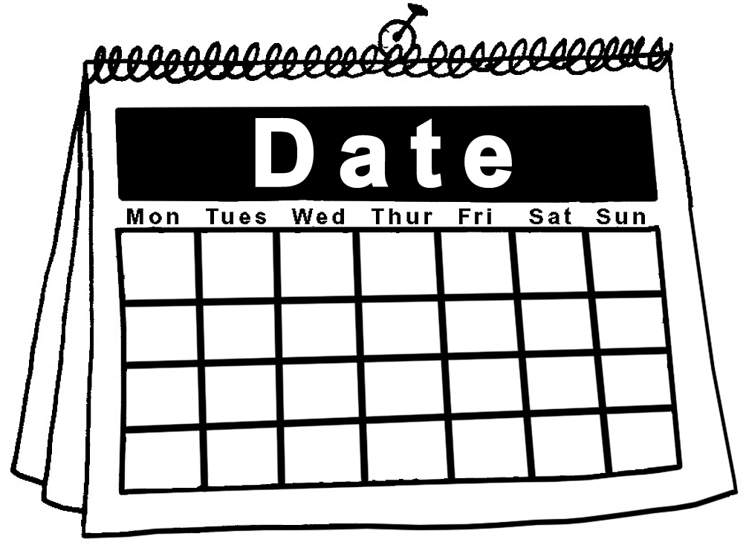
Date of call?

Messages
What is
your
name?
Where
do you
work
or live?
Telephone

Fax

Minicom

e-mail

What is the call about?

Date of call?

Messages
What is
your
name?
Where
do you
work
or live?
Telephone

Fax

Minicom

e-mail

What is the call about?

Date of call?

