April  2010 | May  2010 | June  2010 | July  2010 | August  2010 | September  2010 | October  2010 | November  2010 | December  2010 | January  2011 | February  2011 | March  2011
Making your own plans:  By clicking on any of the boxes on this plan you are free to add your own text.  You can drag the boxes and images into any position you like and copy them if you need more. You can also delete them and insert images of your own choice.  Always save as you go to avoid frustration! |  |  | Project Start: August 2010 | 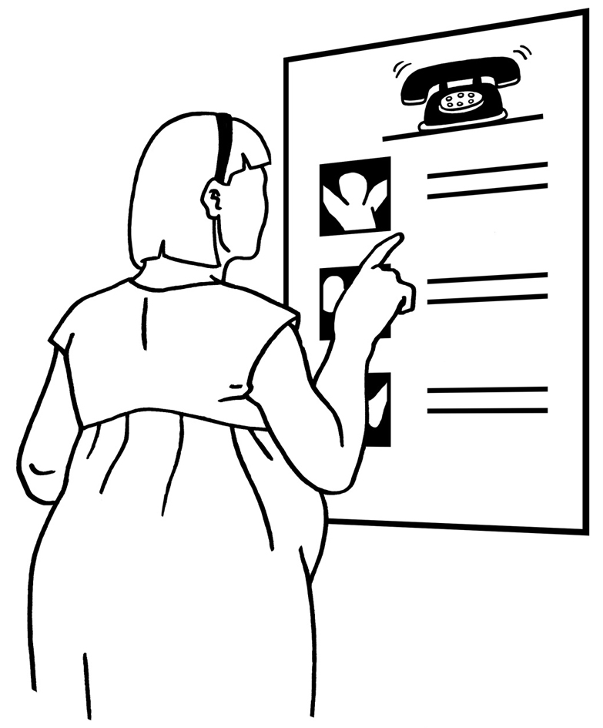  Task:  Find contacts.... |  |  |   Meeting:  Consultation  16th Dec 2010 |  | 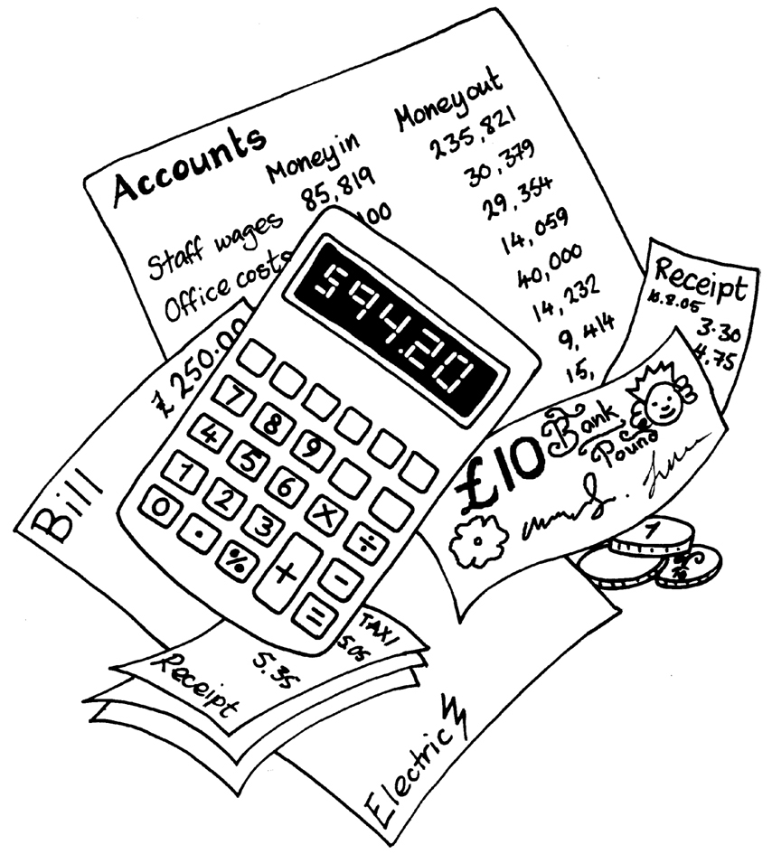 | Text:  Sort bills
 |  | 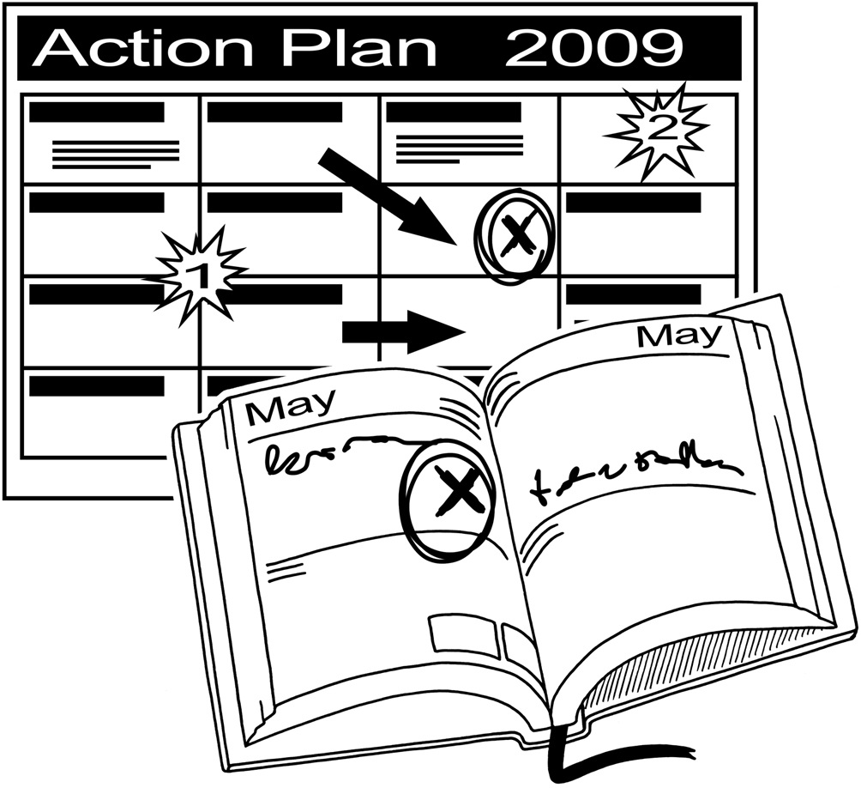  Project description:  This is a 2 year project.... |  | 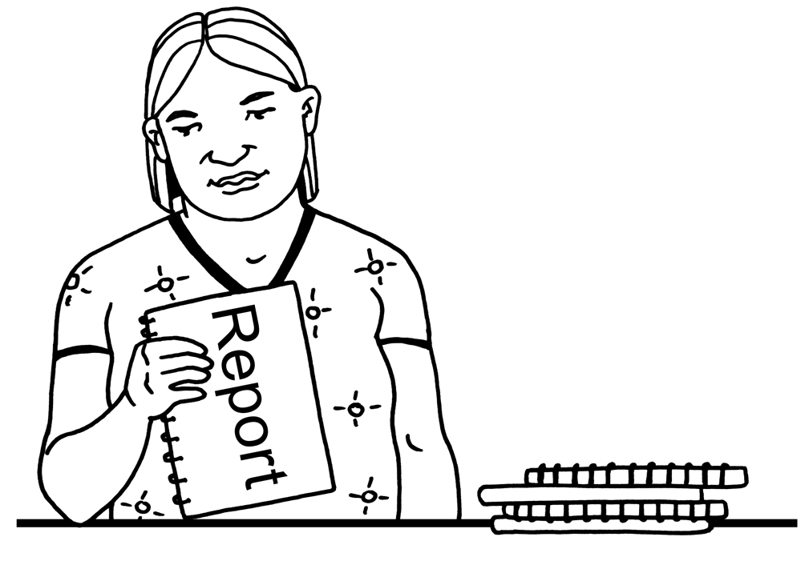  Report  due |  |  | Report  due  Ongoing work: |  |  | Report  due
Aims:  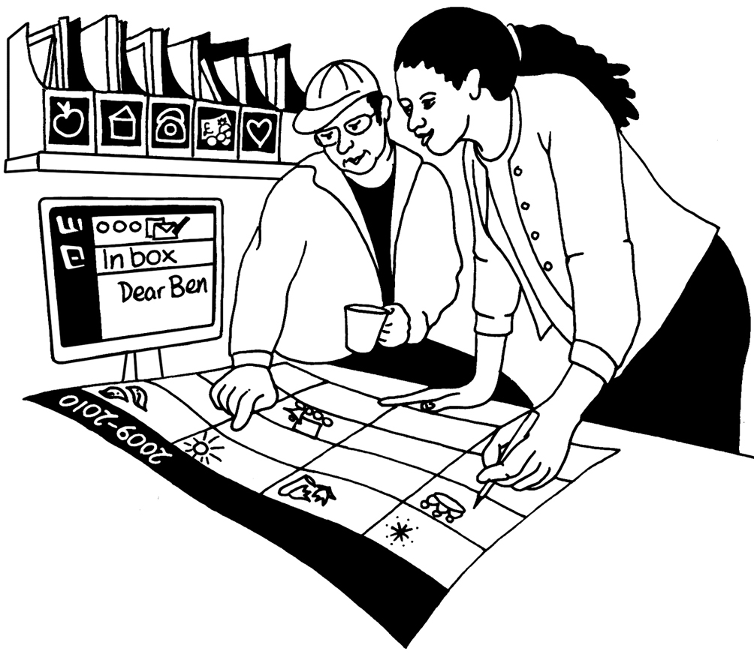 |  |  |  |  | Notes: |  |   Task:  Do a survey... | 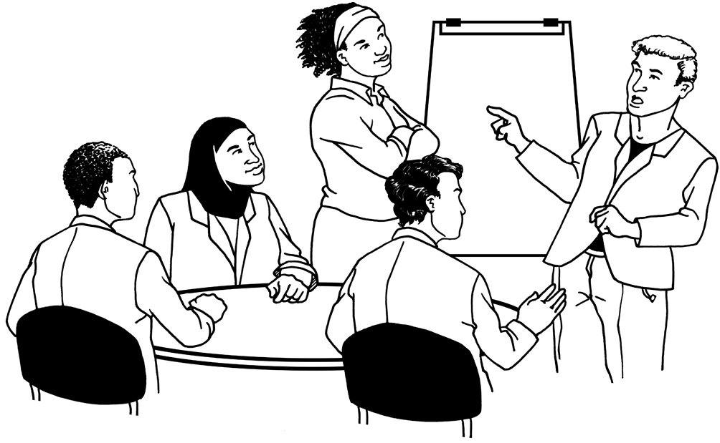 | Event:  Training  22nd Feb 2011 | 
1 | 2 | 3  4 | Annual Leave  3rd- 14th August 10 | 5  6 |  | 7  8 |  |   Ensure that all tasks are done and recorded  9  10 |  | 11 | 12

April  2011 | May  2011 | June  2011 | July  2011 | August  2011 | September  2011 | October  2011 | November  2011 | December  2011 | January  2012 | February  2012 | March  2012
 |  |  | Project half way August 2011
Report
due
1 | 2 | 3  4 |  | 5  6 |  | 7  8 |  | 9  10 |  | 11 | 12

April  2012 | May  2012 | June  2012 | July  2012 | August  2012 | September  2012 | October  2012 | November  2012 | December  2012 | January  2013 | February  2013 | March  2013
 |  |  | Project Finish: August 2012
1 | 2 | 3  4 |  | 5  6 |  | 7  8 |  | 9  10 |  | 11 | 12

